Network Security White Paper
ver.H.1.1

Covered Products:
Model AT-C2
Model AP-C2
Model DI-C1
Model DI-C1L
Model G-P3

Notice
This document May not be reproduced or distributed in whole or in part, for any purpose or in any fashion without the prior written consent of Ricoh Company limited. Ricoh Company limited retains the sole discretion to grant or deny consent to any person or party.
Copyright © 2008 by Ricoh Company Ltd.
All product names, domain names or product illustrations, including desktop images, used in this document are trademarks, registered trademarks or the property of their respective companies. They are used throughout this book in an informational or editorial fashion only. Ricoh Company, Ltd. Does not grant or intend to grant hereby any right to such trademarks or property to any third parties. The use of any trade name or web site is not intended to convey endorsement or any other affiliation with Ricoh products.
Although best efforts were made to prepare this document, Ricoh Company Limited makes no representation or warranties of any kind with regards to the completeness or accuracy of the contents and accepts no liability of any kind including but not limited to performance, merchantability, fitness for any particular purpose, or any losses or damages of any kind caused or alleged to be caused directly or indirectly from this document.

Version history
Version | Issue Date | Revised item
H.1.0 | 30, 10, 2008 | Initial release
H1.1 | 24,11,2010 | Added SSL Features Information

The following terms are used in this document. Please familiarize yourself with them.

Terms:
The products: This refers to the digital multifunction and printing devices covered by this document, as noted in the Model Cross Reference table. The term “the products” refers to all of these machines collectively.
Host Interface: This refers to the physical interface of the Ethernet board on “the products”.
SSL: SSL is a communication technology used for secure connections between 2 hosts. The primary goal of the SSL Protocol is to provide privacy and reliability between two communicating applications. SSL is layered on top of some reliable transport protocol (e.g., TCP). SSL allows the server and client to authenticate each other and to negotiate an encryption algorithm and cryptographic keys before the application protocol transmits or receives its first byte of data.
SSH2 (Secure Shell) is intended as a replacement for rlogin, rsh, and rcp. Additionally, ssh provides secure X connections and secure forwarding of arbitrary TCP connections. Ricoh’s implementation of SSH is based on OpenSSH 3.9.

Model Cross Reference:
Model | Product  Code | Brand
Model | Product  Code | Ricoh | Savin | Gestetner | Lanier | NRG | infotec
Model AT-C2 | D023 D025 | Aficio MP C2800  Aficio MP C3300 | C2828  C3333 | MP C2800  MP C3300 | MP C2800/LD528C  MP C3300/LD533C | MP C2800  MP C3300 | MP C2800  MP C3300
Model AP-C2 | D027  D029 | Aficio MP C4000  Aficio MP C5000 | C4040  C5050 | MP C4000  MP C5000 | MP C4000/LD540C  MP C5000/LD550C | MP C4000  MP C5000 | MP C4000  MP C5000
Model DI-C1 | D038  D041 | Aficio MP C2050  Aficio MP C2550 | C9020  C9025 | MP C2050  MP C2550 | MP C2050/LD520C  MP C2550/LD525C | MP C2050  MP C2550 | MP C2050  MP C2550
Model DI-C1L | D037  D040 | Aficio MP C2030  Aficio MP C2530 | C9020L  C9025L | MP C2030  MP C2530 | MP C2030/LD520CL  MP C2530/LD525c | MP C2030  MP C2530 | MP C2030  MP C2530
Model G-P3 | G190 | Aficio SP C411DN  Aficio SP C410DN | CLP31DN  CLP27DN | C7531dn C7526dn | LP231c/SP C411  LP226c/SP C410 | SP C411DN  SP C410DN | IPC 3030DN  IPC 2525DN
Note: Parts of this document may not apply to some models. For example, printer models do not have scanners. Therefore some uses of RSH (for scanning) do not apply to these models.

Network Security White Paper 1
Covered Products: 1
Notice 2
Version history 3
Terms: 3
Model Cross Reference: 3
Introduction 8
Port Based Network Services and Potential Security Issues 8
TELNET 9
Destruction, corruption and modification of the file system and kernel 9
Possibility of acting as a server for relaying viruses 9
Theft of username and password 9
Possibility of successful DoS (Denial of Service) attacks 9
Recommended precautions 10
FTP 10
Destruction, corruption and modification of the file system 11
Possibility of acting as a server for relaying viruses 11
Theft of username and password 11
Theft of print data 11
Possibility of successful DoS (Denial of Service) attacks 11
Recommended precautions 12
SFTP (SSH2) 12
Destruction, corruption and modification of the file system or kernel 12
Possibility of acting as a server for relaying viruses 12
Theft of username, password, and device information 12
Theft of print data 12
Possibility of successful DoS (Denial of Service) attacks 12
Recommended precaution 13
HTTP 13
Destruction, corruption and modification of the file system 13
Possibility of acting as a server for relaying viruses 13
Theft of username and password 13
Theft of print data 13
Recommended precautions 14
HTTPS 14
Theft of username and password 14
Theft of print data 14
Recommended precautions 15
SNMP v1/v2 15
Destruction, corruption and modification of the file system 15
Theft of community name 15
Possibility of unauthorized parties intercepting device information 15
SNMP v3 16
Destruction, corruption and modification of the file system 17
Theft of username and password 17
Possibility of unauthorized parties intercepting device information 17
Possibility of successful DoS (Denial of Service) attacks 17
SHELL (RSH/RCP) 17
Destruction, corruption and modification of the file system 18
Possibility of acting as a server for relaying viruses 18
Theft of username and password 18
Theft of print data 18
Recommended precautions 18
LPD 18
Possibility of acting as a server for relaying viruses 18
Possibility of successful DoS (Denial of Service) attacks 18
Theft of username and password 19
Theft of print data 19
Recommended precaution 19
IPP 19
Possibility of acting as a server for relaying viruses 20
Theft of username and password 20
Theft of print data 20
Recommended precaution 20
DIPRINT (RAW print) 20
Possibility of acting as a server for relaying viruses 20
Theft of username and password 20
Theft of print data 21
Recommended precautions 21
SMB 21
Possibility of successful DoS (Denial of Service) attacks 21
Theft of username and password 21
Theft of print data 21
Visibility on the network 22
MDNS 22
Possibility of unauthorized parties intercepting device information 22
Recommended precaution 22
H323hostcall/SIP 22
Function Overview 22
Theft of username and password 22
Theft of facsimile data 23
Recommended precaution 23
SSDP 23
Function Overview 23
Possibility of unauthorized parties intercepting device information 23
Recommended precaution 23
WS-Device 23
Function Overview 23
Theft of print or scan data 24
Leakage of device information 24
Recommended precaution 24
IPDS 24
The possibility of acting as a server for relaying viruses 24
Theft of username and password 24
Theft of print data 24
Possibility of successful DoS (Denial of Service) attacks 25
Recommended precaution 25
RHPP 25
Others 25
Other Network Services 25
Wireless LAN 25
Overview 25
SSID only 25
WEP 26
WPA 26
Recommended Precautions 27
IPsec 27
Overview 27
Recommended Precautions 28
Appendix 29
Services requiring open TCP/UDP ports 29
Related Protocols 32
Access Control 34
Access Control – Web Image Monitor 34
Access Control – mshell 38
Disabling Services 39
Disabling Services – Web Image Monitor 43
Disabling Services – mshell 47
HTTP/HTTPS settings 48
SNMP settings: 51
Web Image Monitor 51
mshell 55
Administrator Account Settings 56
Web Image Monitor 56
Network Security Level settings 57
Configuration 57
Description of the Levels 58
Wireless LAN settings 60
Web Image Monitor 60
IEEE 802.1X(WPA/WPA2) 64
mshell 66
IPsec settings 67
Web Image Monitor 67
mshell 72
Reference list 73

Introduction
This document describes potential network threats and recommended precautions for them.
The products have built-in network services for providing a variety of features for wired and wireless network clients, such as network scanning, printing or faxing, and also client services for accessing network servers running outside the products, such as an LDAP server, Netware server, or Mail server.
This document focuses on how-to protect against potential threats from external attacks.
As the products are designed for use inside an Intranet where network clients and servers are protected by firewalls, the products rely on the Intranet’s security policy, like the security provided by other network servers and clients. However, some customers require more strict security levels for network devices, because potential threats from inside the firewalls are increasing, and some configurations even use a secure connection to the Internet as a part of the Intranet.
To satisfy these demands, the products are all evaluated by security scanning applications during development, and also are checked for known vulnerability issues reported by Internet security organizations, such as CERT Coordination Center (CERT/CC : HTTP:// www.cert.org/ ). Whenever we find security vulnerabilities in the products, we provide appropriate countermeasures.

Port Based Network Services and Potential Security Issues
Some MFP/LP services allow write access from network clients. Because of this, some customers may feel that the products are not secure. In fact, the products are secure and provide security measures against potential threats to specific services, but some of these measures can make the services unavailable. For example, disabling the LPD port will make the products unavailable to LPR clients.
Disabling all protocols that are not used is highly recommended. This can be done quickly using Network Security Levels (described in the Appendix section entitled “Network Security Level Settings”). The Network Security Level function can be used to expedite security configuration. Please refer to the Appendix section entitled “Description of the Levels” for information about the configuration and a description of each level.
We also recommend using the Access Control function for added security. Access Control is a list of “safe” client host addresses. Once Access Control is setup for specific IP addresses, the products will receive print or scan requests from the specified hosts only. Access Control can be applied to LPR printing, RSH/RCP access, Bonjour access, HTTP/HTTPS access, FTP printing, TCP raw printing (DIPRINT), SMB printing, IPP printing, scanning from DeskTopBinder. Access Control can also be used for WSD-printing, WSD-Scanning, IPDS printing, and RHPP printing. For information on how to set up Access Control, please refer to the Appendix section entitled “Access Control”.
In the following sections, the potential threats and recommended precautions are given for each service. For added security, the recommended precautions should be accompanied by a firewall and Access Control.

TELNET
Function Overview:
The TELNET service provides a virtual terminal service in order to use the maintenance shell (mshell). It is compliant with RFC 854. The mshell uses TCP port 23 and provides a dedicated command interface for the following functions.
Configuring network settings of the products from remote terminals
Monitoring device status and settings from remote terminals
Getting system logs from remote terminals
Unlike shell services for UNIX/Linux, the mshell provides a command interface for configuration purposes only. Access to the file system or kernel, or modifying system files inside the products is very unlikely.
Potential threats
Destruction, corruption and modification of the file system and kernel
The possibility of destruction, corruption or modification of the file system is very low.
The mshell only permits write-access to a subset of device settings.

Possibility of acting as a server for relaying viruses
This is not an issue. Neither the local file system nor a remote host can be accessed via the mshell.

Theft of username and password
The username and password used for telnet is the same as those used for Web Image Monitor.
Interception of network packets: When accessing the products using TELNET, the username and password are sent in clear text, because the TELNET protocol itself does not support encryption. So if the username and password are intercepted, the possibility of unauthorized access and changes being made does exist.
Brute force password crack:
The RICOH network device can detect a high frequency of failed logins. If the number of login attempts exceeds a configured threshold, the device will send an e-mail to the administrator. All failed logins will be logged.

Possibility of successful DoS (Denial of Service) attacks
The RICOH network device can detect a high frequency of logins and delay responses to that user’s login requests. The device will also send an e-mail to the administrator. The device will log this and a message showing that the device is currently under attack will be displayed in Web Image Monitor.

Recommended precautions
The following are suggested precautions against threats to the embedded TELNET service.
Scenario 1: Basic security settings
Change the username and password from the default value to something difficult to guess and change it regularly.
The username and password are the same as those used for logging into Web Image Monitor in Administrator mode. So, changing the username and password for the mshell means changing them for Web Image Monitor’s Administrator mode.
Scenario 2: High security policy
Close the TELNET port:
The TELNET port can be completely closed using Web Image Monitor. When TELNET is disabled, the services provided by the mshell will not be available. TELNET should only be opened in cases where a machine setting needs to be changed and cannot be changed any other way. Before logging in, the products should be removed from the network and connected to directly be a single PC. After the setting is changed, TELNET should be immediately closed again and can rejoin the network.

FTP
Function Overview
The FTP (File Transfer Protocol) service is compliant with RFC 959. TCP port 20 is used for the FTP-data service and TCP port 21 is used for the FTP-control service. In order to work with the products, FTP clients must be compliant with RFC 959.
The following functions are provided by the FTP service.
- Submitting a print job
- Downloading the files listed in the table below
- Remote Firmware Updates
File name | Description | Attribute
Syslog | System log | Read-only
Stat | Printer Status | Read-only
Prnlog | Print log | Read-only
Info | Printer Information | Read-only
Help | Help | Read-only
Fax application files:  These cannot be seen by users.  rwx - - - - - - | Fax job log  Fax counter  Fax address book | SmartDeviceMonitor for Admin/Client is required to read these files.

RFU requires Machine administrator privileges. When Web Smart Device Monitor is used for RFU, TCP port 10020/10021 are used to send firmware files via the FTP protocol. However, port 21 is used to negotiate the transfer. All 3 ports must be open. RFU is a proprietary process defined by Ricoh and is extremely difficult to emulate. However if a strict security policy is to be maintained, that port can be closed via TELNET.
Potential threats

Destruction, corruption and modification of the file system
Although the FTP service permits write-access, any files that are received by the printer are considered to be a print job or firmware.
When the embedded FTP server receives an executable file, the products prints a binary representation (garbage characters) of the data contained in the executable. As for firmware, a dedicated account and password that are disclosed only to Service Technicians is required to input firmware to the printer using the FTP service. In addition, firmware is verified by checking the header for a digital signature before being used. It would be extremely difficult to make fake firmware. A downgrade (ie. Installing old unsigned firmware) is not allowed by rfu.

Possibility of acting as a server for relaying viruses
This is unlikely. Although the FTP service permits write-access, all written data submitted via the FTP service is treated as a print job or firmware. Any executable would be printed as binary (garbage data).

Theft of username and password
Interception of network packets: The FTP username and the password are sent in clear text because the FTP protocol itself does not support encryption. In fact a username and password are not even necessary when logging into an FTP session.
Brute force password crack:
The RICOH network device can detect a high frequency of failed logins. If the number of login attempts exceeds a configured threshold, the device will send an e-mail to the administrator. All failed logins will be logged.

Theft of print data
Interception of network packets: Using FTP, print data is not encrypted. If intercepted by a third party it is easily read.
Possibility of successful DoS (Denial of Service) attacks
The RICOH network device can detect a high frequency of logins and delay responses to that user’s login requests. The device will also send an e-mail to the administrator. The device will log this and a message showing that the device is currently under attack will be displayed in Web Image Monitor.

Recommended precautions
Never use FTP. Always use SFTP instead of FTP.

SFTP (SSH2)
Function Overview
The SFTP (“Secure File Transfer Protocol” or “SSH File Transfer Protocol”) service provides the same functions as FTP. SFTP uses an SSH (Secure Shell) session over TCP port 22. The SSH provides the following features:
Data Encryption. (Protects against interception/falsification).
For information about OpenSSH, please see:
http://www.openssh.com/
Potential threats
Destruction, corruption and modification of the file system or kernel
Although the SFTP service permits write-access, any files that are received by the printer are considered to be a print job or firmware. If the embedded SFTP server receives anything other than a digitally signed firmware file, the device will print a binary representation (garbage characters) of the data. A dedicated account and password is required to input firmware to the printer using the SFTP service. In addition, the firmware must be digitally signed.

Possibility of acting as a server for relaying viruses
Although the SFTP service permits write-access, any data written to the device (executable or otherwise) is treated as a print job and output as printed pages.

Theft of username, password, and device information
Using SFTP, all data including the username and password is encrypted using DES, 3DES or AES.
Brute force password crack:
The RICOH network device can detect a high frequency of failed logins. If the number of login attempts exceeds a configured threshold, the device will send an e-mail to the administrator. All failed logins will be logged.

Theft of print data
Interception of network packets: Using SFTP, all data sent over the connection is encrypted. Therefore, even if data is intercepted, it will be difficult for unauthorized parties to read.
Possibility of successful DoS (Denial of Service) attacks
The RICOH network device can detect a high frequency of logins and delay responses to that user’s login requests. The device will also send an e-mail to the administrator. The device will log this and a message showing that the device is currently under attack will be displayed in Web Image Monitor.

Recommended precaution
The following are suggested precautions against threats to the SFTP service.
Scenario 1 Basic Security: Change the username and password from the default value to something difficult to guess and change them regularly.

HTTP
Function Overview
The HTTP (Hypertext Transfer Protocol) service provides web services. This service is compliant with RFC 1945. TCP port 80 is used for the HTTP service.
The following functions are provided by the HTTP server service.
- Web Image Monitor
- Document server access via DeskTopBinder.
- Retrieving counter/user information using User Management Tool in SmartDeviceMonitor for Admin/Client
- Access to the products’ address book using Address Management Tool in SmartDeviceMonitor for Admin.
- Submission of a job by an IPP client.
- Providing job status to an IPP client.

Note: When logging into Web Image Monitor in Administrator mode, the user must enter the username and password. It is the same as the username and password used for the mshell.
Potential threats

Destruction, corruption and modification of the file system
Unlikely. Executable files cannot be run on the products’ web server.

Possibility of acting as a server for relaying viruses
Unlikely. Without access to the file system this would be impossible.

Theft of username and password
Interception of network packets: When accessing Web Image Monitor, the password is BASE64 encoded. The password is not sent in clear text, but it is not particularly difficult to decode.
Therefore, if the password is intercepted and decoded, the possibility of unauthorized access and changing of device settings does exist.

Theft of print data
Interception of network packets: Using IPP, print data is sent as clear text. If intercepted by a third party it is easily read.

Recommended precautions
The following are suggested precautions against threats to HTTP service.
Scenario 1: Basic security settings
Change the username and password from the default value to something difficult to guess and change them regularly.
The username and password are the same as those used for logging in to mshell. So, changing the username and password for Web Image Monitor’s Administrator mode means changing them for the mshell as well.
Scenario 1: Standard security settings
Forward HTTP requests to HTTPS.
Whether all, some or none of the HTTP requests received by the MFP are forwarded to HTTPS, depends on the settings (Please refer to the Appendix section entitle “HTTP/HTTPS Settings”).
Scenario 2: High security policy
Close the HTTP port.
The HTTP port can be completely closed with mshell. In this case, both Web Image Monitor and IPP (Internet Print Protocol) are unavailable via HTTP. However, Web Image Monitor and IPP printing are still available via HTTPS.
Note: We recommend using HTTPS instead of HTTP whenever possible.

HTTPS
Function Overview
HTTPS is HTTP over SSL (Secure Socket Layer). HTTPS provides the same functions as HTTP. HTTPS maintains higher security than HTTP because SSL provides the following features:
- Identity verification
- Data integrity verification
- Encryption Potential threats and recommended precaution 1) Destruction, corruption or modification of the file system
The HTTPS service is designed to deny access to the file system and prevent executable files from being run.

Theft of username and password
When using HTTPS, all data including the username and password is encrypted using an encryption algorithm negotiated during the SSL handshake. This is safer than sending username and passwords encoded in Base 64 (using the HTTP).

Theft of print data
Interception of network packets: Using HTTPS, all data sent over the connection is encrypted. Therefore, even if data is intercepted, it will be extremely difficult to use.

Recommended precautions
The following are suggested precautions against threats to the HTTPS service. Scenario 1: Basic security settings
Change the user names and passwords from the default value to something difficult to guess and change them regularly.
Scenario2: High security settings
Disable the web service.
If it is not needed, Web Image Monitor can be disabled using the mshell. When web is set to ‘Down’, Web Image Monitor does not activate and the error “503 Service Unavailable” is displayed. Even when not in use, TCP port 443 stays open and is therefore HTTPS is available for IPP printing.

SNMP v1/v2
The SNMP service is embedded in the products, to provide a method of managing them on the network. This service is compliant with RFC 1157 for SNMP v1 and RFC 1902 for SNMP v2. UDP port 161 is used for the SNMP service and UDP port 162 is used for SNMP-traps.
The following functions use SNMP:
- Configuring the settings of the products.
- Monitoring the status of the products.
- Detecting errors affecting the products.
- Communicating with the client PC for Scanning using the TWAIN driver.
Although the SNMP service is not protected by a password, it is protected using unique community names and assigned access rights (read-only, read-write and trap) within those communities. Access rights allow users read or modify data in the MIB embedded in the products.
Default settings of SNMP community names are follows:
Read-only: public
Read-Write: admin

Potential threats and recommended precautions

Destruction, corruption and modification of the file system
The possibility of destruction, corruption or modification of the file system is very low.
SNMP permits write-access to network parameters only. Access to the file system or kernel is not permitted using SNMP.

Theft of community name
Interception of network packets: Community names are sent in clear text because of the specification of the protocol. Therefore, if intercepted, the community name is easily read.
Possibility of unauthorized parties intercepting device information
Interception of network packets: The products do not respond with important information such as administrator password even if the SNMP client sends a get request for this information. Therefore the security risk is low. However when accessing the products using SNMP, parameters are sent in clear text. The SNMP v1/v2 protocols do not support encryption.
Recommended precautions
The suggested precautions against this threat are as follows.
Scenario 1: Basic security settings
Change the community names from the default value to something difficult to guess and change them regularly.
Note: When the community name settings are changed in the agents, the community name settings in the management utilities must also be changed.
Scenario 2: Standard security settings
Change the setting so that only ‘get’ access using SNMP v1/v2 is allowed (disable ‘set’ access from SNMP v1/v2).
Scenario 3: High security settings
Disable the SNMP v1/v2 service
If it is not absolutely necessary, the SNMP service should be disabled via Web Image Monitor or the mshell.
Scenario 4: Very high security settings
Close the SNMP port
If it is not absolutely necessary, the SNMP port should be closed via Web Image Monitor or the mshell.
Note1: Please refer to the Appendix section entitle “SNMP settings” for details about SNMP settings
Note2: We recommend using the maximum level of security possible. SNMP v3 should always be used in cases where SNMP v1/v2 is not absolutely necessary. Utilities that do not support SNMP v3 will not be able to get device status unless SNMP v1/v2 is enabled. Therefore these utilities will not work correctly if SNMP v1/v2 has been disabled. If your utility does not support SNMP v3 and only requires ‘get’ access to work (doesn’t make any changes to MFP settings), then we recommend security Level 2.

SNMP v3
Function Overview
SNMP v3 provides the same functions as SNMP v1/v2. SNMP v3 maintains higher security than SNMP v1 and v2 because SNMP v3 has the following features:
User Authentication
Data Encryption

Potential threats and recommended precautions

Destruction, corruption and modification of the file system
SNMP only permits write-access to network parameters. Access to the file system or kernel is not allowed.

Theft of username and password
Interception of network packets: When using SNMP v3, the password is hashed using SHA1 or MD5.
Brute force password crack:
The RICOH network device can detect a high frequency of failed logins. If the number of login attempts exceeds a configured threshold, the device will send an e-mail to the administrator. All failed logins will be logged.
Possibility of unauthorized parties intercepting device information
Interception of network packets: The products do not respond with important information such as administrator password even if the SNMP client sends a get request for this information. Therefore security risk is low. In addition the products encrypt other parameters. (Please refer to the Appendix section entitle “SNMP settings”)

Possibility of successful DoS (Denial of Service) attacks
The RICOH network device can detect a high frequency of logins and delay responses to that user’s login requests. The device will also send an e-mail to the administrator. The device will log this and a message showing that the device is currently under attack will be displayed in Web Image Monitor.

Recommended precaution
Scenario 1: Basic security settings
Change the usernames and password from the default value and the passwords for each user to something difficult to guess and change it regularly.
Scenario 2: Standard security settings
Encrypt all data.
Scenario 3: High security settings
Disable the SNMP v3 service.
If it is not absolutely necessary, the SNMP v3 service should be disabled via Web Image Monitor or the mshell.
Scenario 4: Very high security settings
Close the SNMP v3 port.
If it is not absolutely necessary, the SNMP port should be closed via Web Image Monitor or the mshell.

SHELL (RSH/RCP)
The Remote shell (RSH/RCP) services provide the following functions via TCP port 514. This is typically used from a UNIX/Linux client.
- Printing jobs from RSH/RCP clients.
- Monitoring machine status and settings.
- Obtaining the print logs and the system logs.
- Transferring scan data to the Twain driver.
Potential threats and recommended precautions

Destruction, corruption and modification of the file system
Access is read-only.

Possibility of acting as a server for relaying viruses
Because access is read-only, this situation is very unlikely.

Theft of username and password
All data is sent in clear text. However, no password is required for access to RSH/RCP. SFTP is recommended in most situations.

Theft of print data
Using RSH/RCP, print/scan data is sent as clear text. If intercepted by a third party it is easily read.

Recommended precautions
To maintain a strict security policy, the RSH/RCP service can be disabled and the port for this service can be completely closed using Web Image Monitor or the mshell. Note: This will prevent users from TWAIN scanning.
We recommend using SFTP instead of RSH/RCP whenever possible.

LPD
Function Overview
The LPD service is compliant with RFC 1179 and uses TCP port 515 for connections with an RFC 1179 compliant client. The following functions are provided by this service.
Printing a job from LPR clients
Monitoring the status of the printer and print queues from LPR clients.
Deleting print jobs from the print queue by LPR clients.
Potential threats and recommended precaution

Possibility of acting as a server for relaying viruses
The LPD service treats all received data as print jobs. An executable file will print as garbage data.
Possibility of successful DoS (Denial of Service) attacks
The RICOH network device can detect a high frequency of logins and delay responses to that user’s login requests. The device will also send an e-mail to the administrator. The device will log this and a message showing that the device is currently under attack will be displayed in Web Image Monitor.

Theft of username and password
Interception of network packets: LPD does not have an authentication function. However, print data may contain authentication information. This information can be encrypted by the printer driver. Please refer the user manual and driver help for more information about this method.

Theft of print data
Interception of network packets: Using LPR, print data is sent as clear text. If intercepted by a third party it is easily read.

Recommended precaution
As stated above, there are not many threats that apply to the LPD port. However, if a strict security policy is to be maintained, the LPD service can be disabled and the port for this service can be completely closed using Web Image Monitor or the mshell.

Note1: The best way to reduce the possibility of print data being intercepted is to use IPP over HTTPS or SFTP instead of LPR as the printing protocol.

IPP
Function Overview
The IPP (Internet Printing Protocol) service is used for Internet printing from IPP clients. This service is compliant with RFC 2565 and it uses TCP port 631.
The following functions are provided by the IPP service.
- Submission of jobs by an IPP client.
- Job status returned to IPP client.

The IPP service can have up to 10 password protected user accounts for the IPP the service. Both “BASIC” and “DIGEST” authentication are supported. “BASIC” authentication sends the username and password in clear text. “DIGEST” authentication is more secure with the username and password hashed.
Both authentication methods are selectable in Web Image Monitor and mshell.
IPP authentication can also be disabled. In this case, usernames and passwords are not authenticated (The default setting is “disabled”.).
Potential threats and recommended precautions:

Possibility of acting as a server for relaying viruses
The IPP service treats all received data as print jobs. Even if someone sends an executable file via the embedded IPP service, the products print the file as garbage data.

Theft of username and password
Interception of network packets: When the client negotiates the connection with the MFP, the MFP can specify whether the connection uses digest-MD5 hashing for the username and password.

Theft of print data
Interception of network packets: Using IPP, print data is sent as clear text. If intercepted by a third party it is easily read.

Recommended precaution
In order to maintain a strict security policy, we recommend the following precautions.
Scenario 1 Standard Security: IPP Authentication should be either “BASIC” or “DIGEST”. This can be configured in Web Image Monitor, the mshell or the operation panel
“DIGEST” authentication is more secure than “BASIC” because the username and the password are not sent in clear text.
Scenario 2 High Security: Close the IPP port (631/TCP).
If it is not absolutely necessary, the IPP port should be closed via Web Image Monitor or the mshell.
Note1: This only closes the IPP port. The IPP service is still available using HTTP or HTTPS.
Note2: HTTPS is recommended over HTTP or IPP.

DIPRINT (RAW print)
Function Overview.
The DIPRINT (Direct Print or RAW Print) service is Ricoh Company Ltd’s name for port 9100 communication. This service provides direct printing from remote terminals using TCP port 9100.
Potential threats and recommended precautions

Possibility of acting as a server for relaying viruses
The DIPRINT service treats all received data as print jobs. An executable file submitted to the embedded DIPRINT service would be printed as garbage data.

Theft of username and password
Interception of network packets: Print data may contain authentication information. This information can be encrypted by the printer driver. Please refer the user manual and driver help for more information about this method.

Theft of print data
Interception of network packets: Depending on device and driver settings, print data might be sent as clear text. In this case, if intercepted by a third party, it is easily read.

Recommended precautions
If a strict security policy is needed, the DIPRINT port can be changed or closed using Web Image Monitor or the mshell.
Note1: To reduce the possibility of print data being intercepted, please use HTTPS instead of DIPRINT to submit jobs.

SMB
The SMB service uses NBT (NetBIOS over TCP/IP) as its base layer.
The NBT service provides the NetBIOS service over TCP/IP instead of NetBEUI. Using this service, a remote host can access network services of the products by the NetBIOS name (Computer Name) instead of IP address. This service uses 3 ports, UDP port 137 for NetBIOS-NS (NetBIOS Name Service), UDP port 138 for NetBIOS-DGM (NetBIOS Datagram Service) and TCP port 139 for NetBIOS-SSN (NetBIOS Session Service). SMB (Server Message Block) over TCP/IP provides the following services:
- Browsing print servers from SMB clients
- Installing Point and Print drivers to clients
- Printing jobs from SMB clients
- Sending job queue information to SMB clients
- Sending notifications of job completion to SMB clients

Potential threats and recommended precautions

Possibility of successful DoS (Denial of Service) attacks
The RICOH network device can detect a high frequency of logins and delay responses to that user’s login requests. The device will also send an e-mail to the administrator. The device will log this and a message showing that the device is currently under attack will be displayed in Web Image Monitor.

Theft of username and password
Interception of network packets: The SMB protocol has authentication but a guest account can be configured. Some print data may contain authentication information. The password can be encrypted by enabling the printer driver’s encryption function before sending data to the MFP. Please refer to the user manual and driver help for more information about this function.

Theft of print data
Interception of network packets: Using SMB, print data is sent as clear text. If intercepted by a third party in is easily read.

Visibility on the network
To protect the products from being browsed by unauthorized parties, NetBIOS-NS and NetBIOS-DGM services should be disabled using the mshell.
Recommended precaution
Scenario 1 Standard Security:
Use Point and Print only with digitally signed drivers.
Scenario 2 High Security:
Disable SMB. Use only IPP (with ssl) to submit jobs.

MDNS
Function Overview
MDNS (Multicast DNS) is a way of using familiar DNS programming interfaces, packet formats and operating semantics, in a small network where no conventional DNS server has been installed.
The products only use MDNS for Bonjour. If Bonjour is not being used, this port can be closed.
Potential threats and recommended precaution
Possibility of unauthorized parties intercepting device information
This is a possibility. The products use MDNS to advertise services and device information. If this is a concern, please close the port.

Recommended precaution
If a strict security policy is to be maintained, the MDNS service can be disabled and the port for this service can be completely closed using Web Image Monitor or the mshell. (If Bonjour is turned off, the MDNS port is closed automatically.)

H323hostcall/SIP

Function Overview
H323/SIP services are used to provide VoIP (Voice over IP) for IP-Fax. The H.323 hostcall service is compliant with ITU-T standards and uses TCP port 1720. The SIP service is compliant with RFC3261 and uses TCP/UDP port 5060.
Potential threats and recommended precautions

Theft of username and password
The SIP protocol has an authentication function. However the products do not support authentication using the SIP protocol. Therefore the username and password are not included with data sent over this protocol.

Theft of facsimile data
Interception of network packets: Using IP-Fax, facsimile data is formatted for an ISDN connection and is not encrypted. If intercepted by a third party it can be read.

Recommended precaution
If a strict security policy is to be maintained, the TCP/UDP ports for H323hostcall (1720) and for SIP (5060) can be changed or closed. However, these services cannot be stopped.

SSDP

Function Overview
SSDP (Simple Service Discovery Protocol) is used for both advertising services and searching for services on UPnP network. SSDP uses UDP port 1900. If UPnP is not being used, this port can be closed.
Potential threats and recommended precautions

Possibility of unauthorized parties intercepting device information
The products use SSDP to advertise services and search for services. If this is a concern, the SSDP service should be disabled using Web Image Monitor or the mshell.

Recommended precaution
If a strict security policy is to be maintained, the SSDP service can be disabled and the port for this service can be completely closed using Web Image Monitor or the mshell.

WS-Device

Function Overview
WS-Device (‘Web Service’ Device) is a Windows Vista standard. This service is compliant with ‘Device Profile for Web Services (February 2006)’.
The following functions are provided by the WS-Device service.
- Advertising the existence of the printing service. (WS-Discovery)
- Printing/Scanning jobs to a WS-Device client. (WS-Printer/WS-Scanner)
- Providing the printer status to other WS-Device clients. (WS-Eventing)
- Providing details about the device and available services. (WS-Transfer / WS-MetadataExchange)
This service uses the following TCP/UDP ports:
TCP/UDP 3702: Used for the device advertisement (WS-Discovery)
TCP 53000: Used for WS-Device (WS-Transfer / WS-MetadataExchange)
TCP 53001: Used for WS-Printer/WS-Scanner(WS-Printer/WS-Scanner/ WS-Eventing)
TCP 53002: Used for WS-Scanner(WS-Scanner)

If a strict security policy is to be maintained, the WS-Device service can be disabled and the port for this service can be completely closed using Web Image Monitor or the mshell.
Potential threats and recommended precautions

Theft of print or scan data
Interception of network packets: The WS-device encodes data but does not encrypt it. Print or scan data is sent as clear text. If intercepted by a third party it is easily read.
Leakage of device information
The products use WS-Device to advertise services and allow the user to know the device status and to print documents. If you do not want to unauthorized parties to be aware of this information, the WS-Device service should be disabled using Web Image Monitor or the mshell.

Recommended precaution
If a strict security policy is to be maintained, the WS-Device service can be disabled and the ports for this service can be completely closed using Web Image Monitor or the mshell.

IPDS
Function Overview
Intelligent Printer Data Stream (IPDS) is a structured field data stream. It allows both data and commands to be streamed to the printer via channels, controllers or any type of networking link, which supports the transparent transmission of data to print processes that are resident in the device.
This service uses following TCP/UDP port:
TCP 5001: Used for transmitting data and printer control commands.
Potential threats and recommended precautions

The possibility of acting as a server for relaying viruses
The IPDS service treats all received data as print jobs and job control commands.

Theft of username and password
Interception of network packets: IPDS print can not be authenticated by the printer. Therefore, there is no username and password in the IPDS print data.

Theft of print data
Interception of network packets: Using IPDS, print data is not encrypted. If intercepted by a third party, it is possible to read.

Possibility of successful DoS (Denial of Service) attacks
The RICOH network device can detect a high frequency of logins and delay responses to that user’s login requests. The device will also send an e-mail to the administrator. The device will log this and a message showing that the device is currently under attack will be displayed in Web Image Monitor.

Recommended precaution
If a strict security policy is to be maintained, the IPDS service should not be installed. In addition it can be disabled and the port for this service can be completely closed using Web Image Monitor or the mshell.

RHPP
Though MFPs of all regions support RHPP, Ricoh has not released any RHPP servers outside of Japan. So we do not force the need for this service in the near future. Please close the ports.
This service uses the following TCP/UDP port:
TCP 59100: Used for transmitting data and printer control commands.
Note1: As of 2008, there are no RHPP print servers on the market outside of Japan.

Others
TCP port 7443 and 7444 are reserved for @Remote. If a strict security policy is to be maintained, those ports can be closed via TELNET. (Please refer to the Appendix for a list of ports)
HTTPS is used for this service as an underlying layer. Please refer to the “HTTPS” section for the potential threats and recommended precautions for HTTPS.

Other Network Services
The Previous section dealt mainly with physical port based network services. This section will describe security related information for network services not based on physical ports.

Wireless LAN

Overview
WLAN utilizes spread spectrum technology based on radio waves to enable communication between devices in a limited area. This gives users the mobility to move around within a broad coverage area and still be connected to the network. The absence of cables leaves transmissions extremely susceptible to interception. For this reason a variety of security precautions have been incorporated into WLAN specifications.

SSID only
All data is sent as clear text without any authentication or integrity checking. As wireless data is available to anyone within range, unencrypted data is extremely susceptible tampering and theft.

WEP
‘WEP’ (Wired Equivalent Privacy) is a security standard settled on by IEEE, and adopted as IEEE802.11. Using WEP, data can be encrypted with a shared key (RC4). Access to the network is based on a WEP key configured on the clients and the Access Points. Although WEP provides a degree of security, it does have vulnerabilities. ‘WPA’ was created to overcome the vulnerabilities in WEP. The products support both WEP and WPA.

WPA
‘WPA’ (WiFi Protected Access) is a subset of IEEE802.11i. It utilizes a key exchange system to constantly change the shared key. This re-keying can be done using either TKIP or CCMP. However support for WPA2 is required for CCMP. TKIP uses RC4 as an encryption algorithm and is intended for use with legacy systems that do not yet support CCMP. In addition to providing key exchange, CCMP uses the AES encryption algorithm which is a stronger than RC4.
Yes / Yes
No / No
Key exchange / refresh
128 bit
104 bit
40/104 bit
Shared key size
AES
RC4
RC4
Encryption algorithm
CCMP
TKIP
WPA
WEP
Encryption method

WPA employs four authentication modes: ‘WPA-PSK’, ‘WPA2-PSK’, ‘WPA (802.1X)’ and ‘WPA2 (802.1X)’. WPA-PSK and WPA2-PSK are similar to WEP in that a pre-shared key is used to join the network. However, a new encryption key is generated in handshake process, making WPA-PSK and WPA2-PSK more secure than WEP. WPA (802.1X) and WPA2 (802.1X) are much more strict than the PSK protocols. Only users that can be authenticated by a RADIUS server using EAP are allowed to join the network. Supported EAP authentication types are:
EAP-TLS
EAP-TTLS
PEAP
LEAP

Potential Threats

SSID only (no encryption)
All data (including the SSID) is transmitted in plain text. It is easily readable by anyone within range of the wireless transmission.

WEP
WEP provides RC4 encryption of data and is therefore more secure than using only an SSID. However the weaknesses of RC4 encryption and WEP in general are well documented. Note: WPA TKIP uses RC4. However, because the keys are being constantly refreshed, the key will change before it can be cracked.

WPA
In WPA, the encryption key is generated at interval by TKIP or CCMP. The key does not need to be entered manually. As the key is refreshed so often, a brute force attack is almost impossible. Furthermore, CCMP uses AES, which is a stronger encryption method than RC4. As an added precaution, WPA (802.1X) /WPA2 (802.1X) provide user authentication.

Recommended Precautions
Please take the appropriate action for your security policy.
Scenario 1: Basic security settings
General Access Point settings
Prohibit broadcast of the SSID.
Prohibit connections that do not have the correct SSID.
Limit connections to only specific MAC addresses.
We recommend against using security Level 1.
Scenario 2: Standard security settings
WEP
We recommend making regular changes to the PSK.
Scenario 3: High security settings
WPA-PSK/WPA2-PSK
Scenario 4: Very high security settings
WPA (802.1X)/WPA2 (802.1X) instead of WPA-PSK/WPA2-PSK.
Please refer to the Appendix section entitled “Wireless LAN Settings” for an explanation of how to configure these settings.

IPsec

Overview
Internet Protocol Security (IPsec) is a suite of protocols which provides secure communication over the network layer. IPsec provides authentication, data integrity, and protection against replay attacks. Unlike SSL which functions between the application and transport layers, IPsec functions in the network layer.
The products can offer the following header extensions.

AH
Authentication, integrity (IP header and the payload).
No encryption.

ESP
Authentication, encryption, (payload only).

AH+ESP
Authentication, encryption, (IP header and the payload).
The Ricoh implementations for the encryption and authentication algorithm are:
Encryption:
Clear Text (No encryption)
DES
3DES
AES-128
AES-192
AES-256

Authentication:
HMAC-MD5-96
HMAC-SHA1-96

The encryption or authentication keys can be set manually or generated automatically using IKE.
Note: IPsec are disabled for DHCP, DNS, WINS, and HTTPS by default. IPsec can be applied to these protocols by enabling it in mshell.

Recommended Precautions
The suggested precautions are as follows.
Key Exchange:
Use IKE instead of the manual key exchange. If the encryption or authentication keys have to be set manually, there will be no re-keying. The same keys will be used until manually changed again.
Security Protocol:
Scenario 1 Basic: AH
No encryption.
Selectable authentication algorithm.
Scenario 2 Standard: ESP
Payload is encrypted.
Selectable authentication algorithm.
Scenario 3 High: ESP+AH
Very secure.
Encryption of the payload and headers
Data integrity
Authentication
Please refer to the Appendix section entitle “IPSEC Settings” for an explanation of how to configure these settings.

Appendix
Services requiring open TCP/UDP ports
Protocol | Port Num. | Login | Username Changeable | Password | Password  Changeable | Note
TELNET | 23/TCP | Y | Y | Y | Y | This is the same username and password as are used for Web Image Monitor.
FTP-control | 21/TCP | Y | N | N | N | For RFU, administrator privilege is required.
HTTP | 80/TCP | Y | Y | Y | Y | This is the same username and password as are used for TELNET. The unauthorized users can only read access is available.
netbios-ns | 137/UDP | N | N | N | N
netbios-dgm | 138/UDP
netbios-ssn | 139/TCP
SNMP | 161/UDP | Y | Y | N | N | Although there is no concept of user accounts, it can perform access restrictions using the Community Name. Up to 10 Communities can be registered.
SNMPv3 | 161/UDP | Y | Y | Y | Y | This is the same username and password as are used for TELNET. If no password is input, then only read access is available.
HTTPS | 443/TCP | Y | Y | Y | Y | This is the same username and password as are used for TELNET. If no password is input, then only read access is available.
RSH/RCP (shell) | 514/TCP | N | N | N | N
LPD | 515/TCP | N | N | N | N
IPP | 631/TCP | Y | Y | Y | Y | Authentication by account/password is not performed by default. In this case all users are ANONYMOUS. When IPP authentication is enabled, a username and password will be required.
H323gatestat | 1719/UDP | N | N | N | N | If the products are configured to use ‘gatekeeper’, this port is opened so the products can register its information with gatekeeper.
H323hostcall | 1720/TCP | N | N | N | N
SSH | 22/TCP | Y | Y | Y | Y | SSH is only used for SFTP. For RFU, administrator privilege is required. For SFTP, RFU is not available via Web Smart Device Monitor.
SIP | 5060/TCP, UDP | N | N | N | N | The SIP protocol supports authentication. However we do not support SIP authentication with our products.
MDNS | 5353/UDP | N | N | N | N
@Remote | 7443/TCP  7444/TCP | - | - | - | -
SSDP | 1900/UDP | N | N | N | N
DIPRINT | 9100/TCP | N | N | N | N
RFU | 10021/TCP | Y | - | - | - | This port functions similarly to an FTP port and used for Web Smart Device Monitor.
WS-Printer | 53001/TCP | N | N | N | N
WS-Scanner | 53002/TCP | N | N | N | N
WS-Device  WS-Discovery | 53000/TCP  3702/TCP | N | N | N | N
IPDS | 5001/TCP | N | N | N | N
RHPP | 59100/TCP | N | N | N | N

Related Protocols
Protocol | Protocol Suite | Commonly Used Port Num. | Description of the protocol’s function in the Products.
IP | TCP/IP | - | -
ICMP | TCP/IP | Protocol Num. 1 | -
UDP | TCP/IP | Protocol Num. 17 | -
TCP | TCP/IP | Protocol Num. 6 | -
FTP-data | TCP/IP | 20/tcp, udp | 1) Sending scan data to the FTP server. (Scan to FTP)  2) Sending scan data to ScanRouter
FTP-control | TCP/IP | 21/tcp, udp
SMTP | TCP/IP, IPX/SPX | 25/tcp, udp | 1) Sending scan data to the SMTP server. (Scan to E-mail)
Domain (DNS) | TCP/IP | 53/tcp, udp | 1) Resolving IP addresses from the server name.
BOOTP  DHCP | TCP/IP | 67/tcp, udp  68/tcp, udp | 1) Getting IP addresses and other network parameters from the DHCP server.
POP | TCP/IP | 110/tcp, udp | 1) Using POP before SMTP authentication for ‘Scan to E-mail’.  2) Receiving internet-fax data.
SNTP | TCP/IP | 123/tcp, udp | 1) Getting UTC from the NTP server.
NETBIOS-NS | TCP/IP, IPX/SPX, NetBEUI | 137/tcp, udp | 1) Sending scan data to SMB clients. (Scan to SMB)
NETBIOS-DGM | TCP/IP, IPX/SPX, NetBEUI | 138/tcp, udp | 1) Sending scan data to SMB clients. (Scan to SMB)
NETBIOS-SSN | TCP/IP, IPX/SPX, NetBEUI | 139/tcp, udp | 1) Sending scan data to SMB clients. (Scan to SMB)
IMAP | TCP/IP | 143/tcp, udp | 1) Getting internet-fax data
SNMP-trap | TCP/IP, IPX/SPX | 162/tcp, udp | 1) Sending status information to Network Management Server.
LDAP | TCP/IP | 389/udp, tcp | 1) Searching e-mail addresses from the LDAP server’s address book.
syslog | TCP/IP | 514/udp | 1) Sending system logs to a syslog server.
NCP | TCP/IP, IPX/SPX | 524/tcp, udp | 1) Logging in to a Netware server.  2) Printing from the Netware environment.
SLP | TCP/IP | 427/tcp, udp | 1) Searching for a Netware Server.
IPX | IPX/SPX | - | 1) Providing ipx connections
SPX | IPX/SPX | - | 1) Providing spx connections
SAP | IPX/SPX | - | 1) Broadcasts to availability of print services.
RIP | IPX/SPX | - | 1) Broadcasts route information.
APPLETALK | APPLETALK | - | 1) Providing appletalk connections.
PAP | APPLETALK | - | 1) Providing appletalk printing services
NETBEUI | NETBEUI | - | 1) Providing netbeui connections.
IKE | IPsec | 500/udp | 1) Providing IKE connections.

Commonly Used Port Number: This is meant to be general information. This column contains well-known port numbers commonly used in industry. This is not necessarily the port used by the products.

Access Control
The printer will accept communication only from a set range of IP addresses. This can be applied to connections from LPR, RSH/RCP, HTTP, HTTPS, Bonjour, SSH/SFTP, FTP, DIPRINT, SMB, IPP, WS-Device, WS-Printer, WS-Scanner, IPDS, RHPP, and DeskTopBinder.
These cannot be applied to TELNET or SmartDeviceMonitor.

Access Control – Web Image Monitor
Web Image Monitor can be used for accessing the products. A supported Browser such as Microsoft Internet Explorer and the product’s IP address is required. 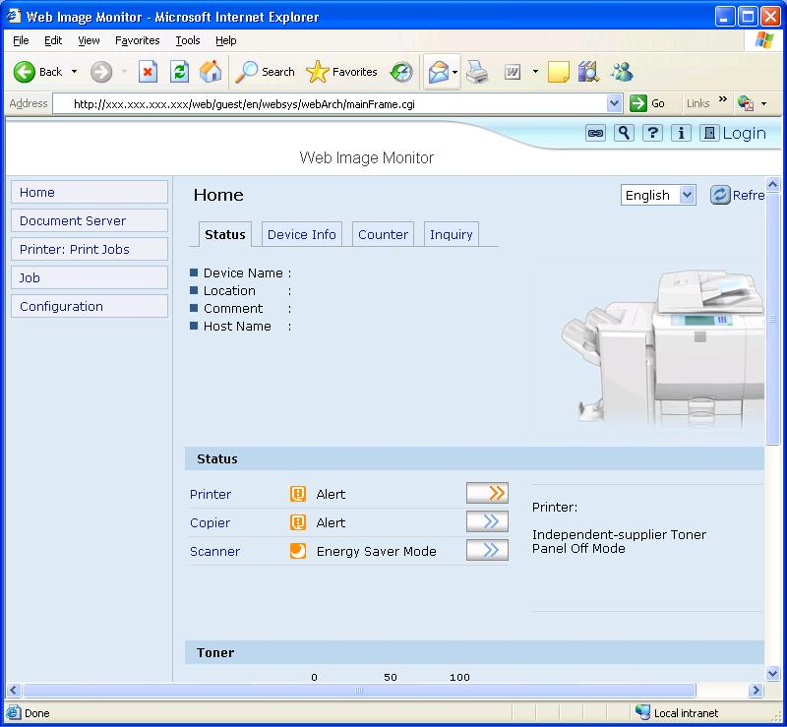
Login as Administrator.
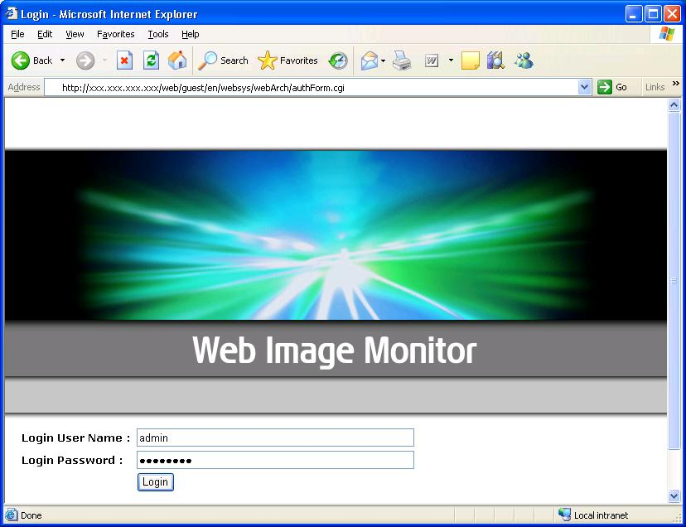

The 4 administrator types are identified as follows:
: Machine Administrator
: Network Administrator
: User Administrator
: File Administrator
By default, all administrator privileges are merged into one administrator. If Admin Auth is enabled then Network Administrator privileges are required in order to use Access Control.
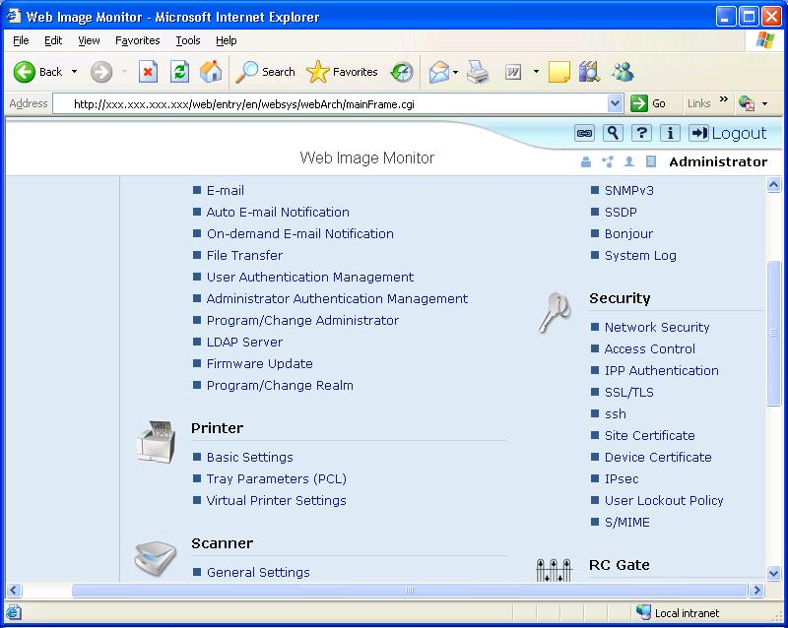
Input the range of IP addresses that you wish to permit communication with.
Click the ‘OK’ button to commit the changes.
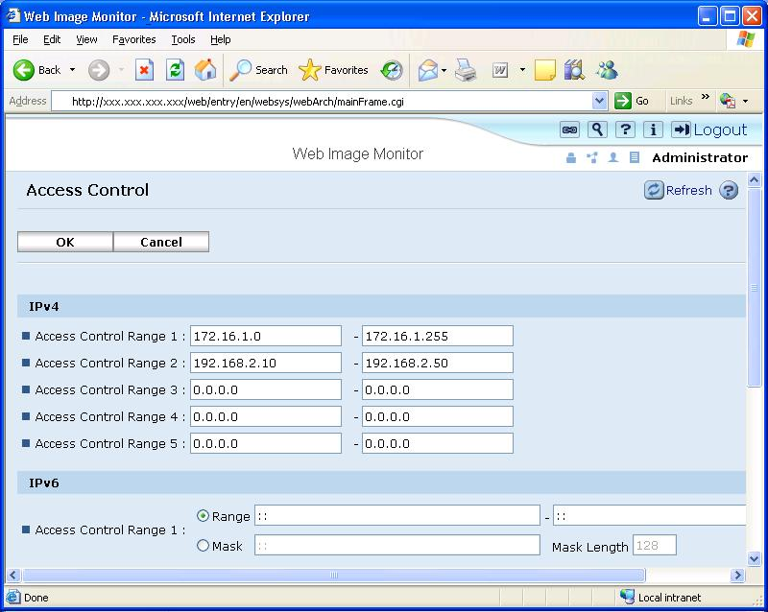

Access Control – mshell
The following example is shown using the Windows XP telnet client.
Telnet into the Maintenance Shell (mshell). A username and password will be required for this. Using the access command input the access control range.
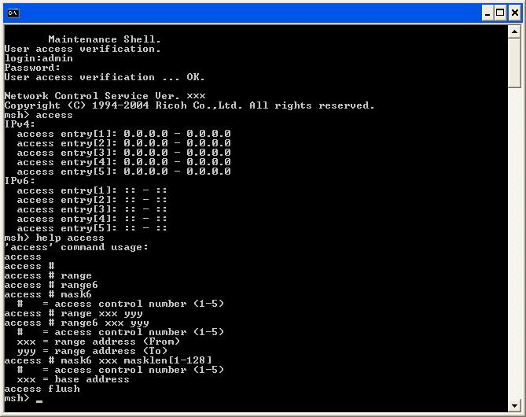
E.g.1 Input the following command to permit only access from 172.16.1.0 to 172.16.2.0
msh> access 1 range 172.16.1.0 172.16.2.0
E.g.2 Input the following command to clear all access ranges.
msh> access flush
If changes have been made, the following question will appear when the user tries to logout. ‘Do you save configuration data?’ Input ‘yes’ to commit the changes. Input ‘no’ to discard them.
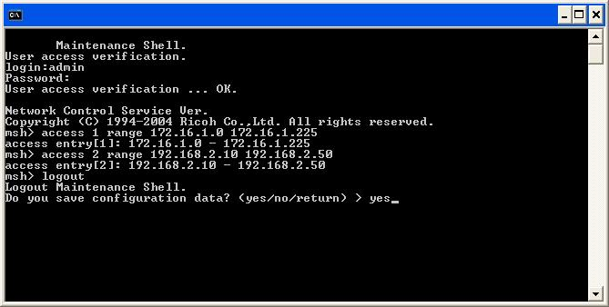

Disabling Services
The following table describes whether services or ports can be opened or closed using Web Image Monitor and/or mshell.
See “Network Security Level Settings” for more information.
Note: Some ports cannot be closed via the above settings. See comments in table below.
Service/Protocol | Port | Web Image Monitor |  | mshell |  | Comment
Netware | - | Y |  | Y |  | Setting Netware to down, disables the IPX/SPX protocol and NCP/IP. Therefore if Netware is down, printing in the IPX/SPX environment and in the pure IP environment is unavailable. LPR in NDPS and iPrint (IPP Printing) are unaffected.
AppleTalk | - | Y |  | Y
 |  | IPv4 | IPv6 | IPv4 | IPv6
TCP/IP | - | Y | Y | Y | Y | It is not possible to set own TCP/IP version via Web Image Monitor. For example, in order to disable TCP/IPv4, it needs to be connected via TCP/IPv6.
FTP | 21 | Y | Y | Y | Y | Setting FTP to down, closes FTP port (21/tcp). The FTP server service will be down but the FTP client function is still available. Therefore if this function is down, Scan to FTP is still available.
SSH/SFTP | 22 | Y | Y | Y | Y | If either of ssh or sftp is set to down, this port will be closed.
TELNET | 23 | Y | Y | - | - | Telnet cannot be disabled via mshell for obvious reasons.
SMTP | 25 | Y | - | - | - | Configuration > E-mail > Reception Protocol > ‘POP3’ or ‘IMAP4’.
HTTP | 80 | Y | Y | Y | Y | setting web down’ does not close this port. In order to close this port open mshell and type ‘set http down’.  In order to close this port via Web Image Monitor, it needs to be connected via HTTPS or IPv6.
IPP | 631 | Y | Y | Y | Y
NBT | 137/138 | Y | - | Y | - | Setting NBT to down, closes NetBIOS-NS (137/UDP) and NetBIOS-DGM (138/UDP)
SMB | 139 | Y | - | Y | - | Setting SMB to down, closes NetBIOS-SSN (139/TCP).
SNMP | 161 | Y | Y | Y | Y | Use Web Image Monitor’ to close this port.  Setting SNMP to down, closes SNMP port (161/udp). In addition when SNMP is down, the SNMP trap function and SNMP function over IPX/SPX is not available.
SSL | 443 | Y | Y | Y | Y | HTTP and HTTPS cannot both be closed at the same time from Web Image Monitor.
RSH/RCP | 514 | Y | Y | Y | Y
LPR/LPD | 515 | Y | Y | Y | Y
H.323 | 1720 | Y | - | - | - | In order to close this port:  Configuration > Fax > IP-Fax Settings > Enable H.323 > ‘Off’ (Web Image Monitor).  This port cannot be closed via mshell.
SSDP | 1900 | Y | - | Y | - | Setting SSDP to down makes UPnP unavailable and closes the SSDP port (1900/UDP)
MDNS | 5353 | Y | - | Y | - | In order to close this port, set ‘Bonjour’ to down.
SIP | 5060 | Y | - | - | - | In order to close this port: Configuration > Fax > IP-Fax Settings > Enable SIP > ‘Off’ (Web Image Monitor).  This port cannot be closed via mshell.
@Remote | 7443/7444 | - | - | Y | - | In order to disable this service, type ‘set nrs down’ in mshell.
DIPRINT | 9100 | Y | Y | Y | Y | If this port is closed, printing from diprint clients is unavailable.
RFU | 10021 | - | - | Y | Y | If this port is closed, remote firmware update will still be available via ftp. However, if RFU is to be used, we recommend keeping this port open as the ftp password is sent in clear text.
RHPP | 59100 | Y | Y | Y | Y | If this port is closed, RHPP is not available.
IPDS | 5001 | Y | - | Y | -
WS Discovery /  WS Device | 3702  53000 | Y | Y | Y | Y | When either WS Device or WS Printer/WS Scanner is disabled via Web Image Monitor or mshell, these ports are both closed.
WS Printer  WS Scanner | 53001  53002 | Y |  | Y

Disabling Services – Web Image Monitor

Select IPv4 to disable the protocols for IPv4.
Select IPv6 to disable the protocols for IPv6.

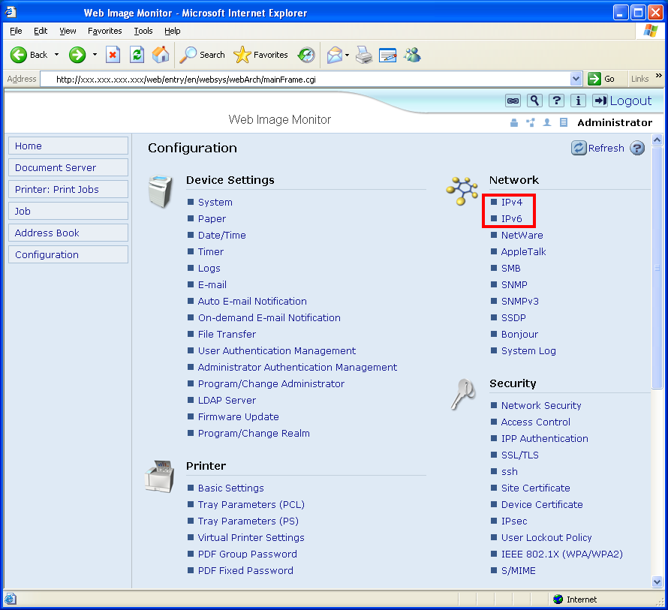

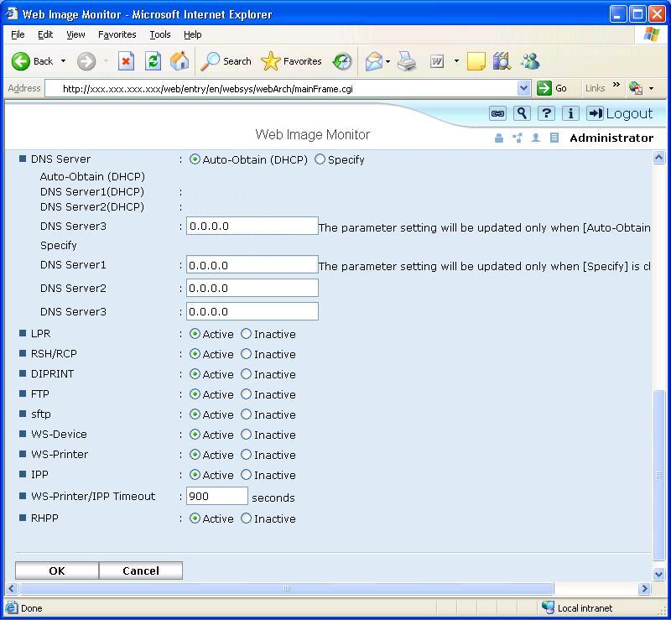

Security > Network Security
Services can be disabled from Network Security page as well.
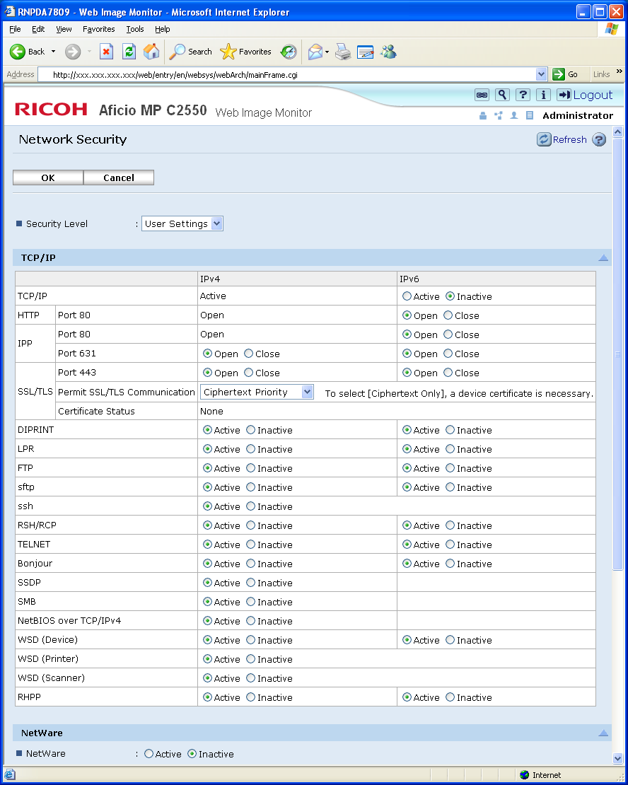

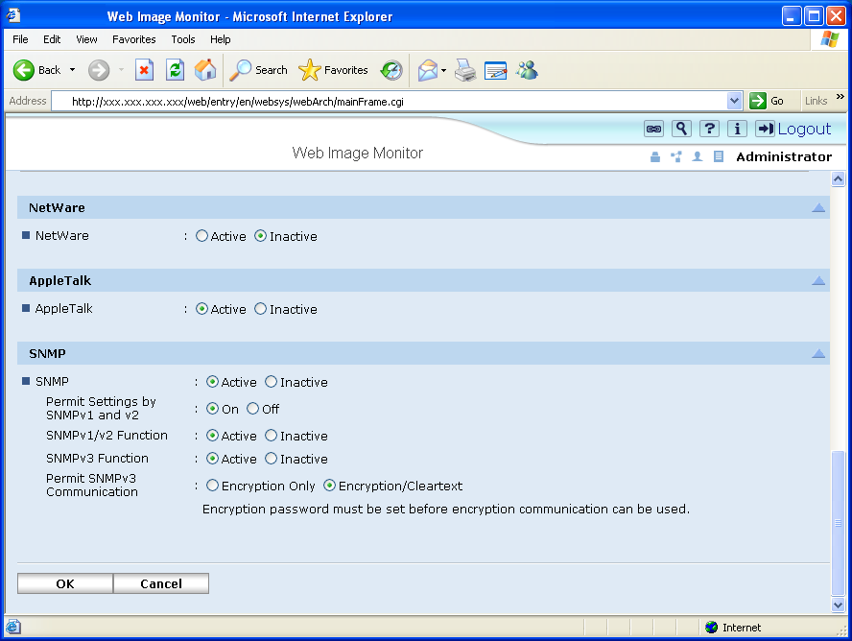

Disabling Services – mshell
Set <service> up/down
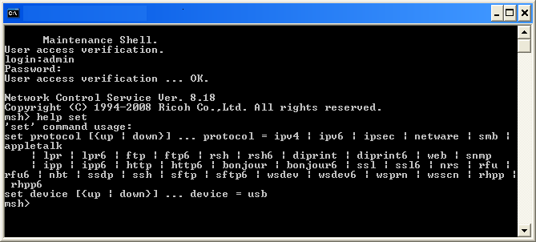

After saving, the user will be prompted to save or discard changes.
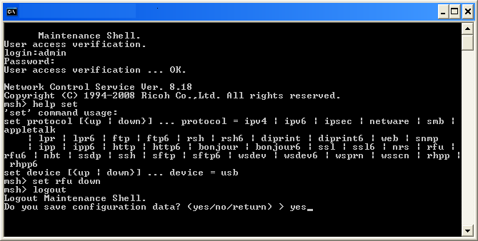

HTTP/HTTPS settings
Security > SSL/TLS
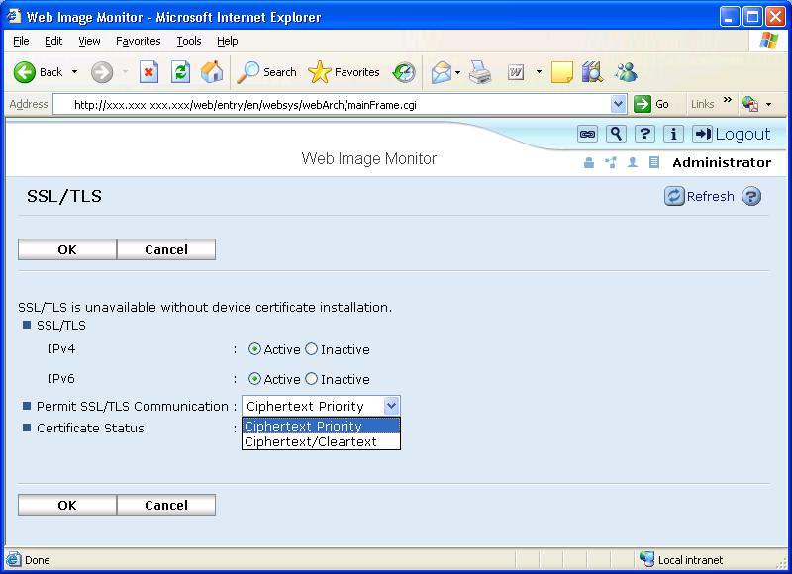

Permit SSL/TLS Communication
- Ciphertext/Clear Text: Permit both HTTPS and HTTP connections. No forwarding of HTTP to HTTPS.
- Ciphertext Priority: Any incoming HTTP request that can be forwarded to HTTPS, will be forwarded. With this setting it will be possible to use HTTPS from Internet Explorer, Netscape Navigator, etc. (HTTP will be forwarded) but not using IPP from SmartDeviceMonitor for Client etc. (these requests can not be forwarded). If the request cannot be forwarded to HTTPS, HTTP will be permitted.
- Ciphertext Only: Permit only HTTPS connections. All incoming HTTP requests will be forwarded to HTTPS. If the request cannot be forwarded, the connection will be rejected.

HTTP/HTTPS settings
Security > SSL/TLS
In addition to the features described on the previous page, this feature is new .
Note:
The new features will only appear if specific versions of the firmware are applied:
MFP Model | Network Support | Web Support
AT-C2 | 8.30 or later | 1.11 or later
AP-C2 | 8.30 or later | 1.11 or later
DI-C1/DI-C1L | 8.30 or later | 1.01 or later

Printer Model | Network Support | Web Support | Printer Support
G-P3 | 8.06 | 1.06 | 1.08

Q: What has been changed?
A: Implementation of some of the NIST recommendations for cryptographic algorithms and key lengths (outlined in SP 800-131).

NIST SP 800-131
- http://csrc.nist.gov/publications/drafts/800-131/draft-sp800-131_spd-june2010.pdf

The ability to enable/disable specific versions of SSL/TLS:

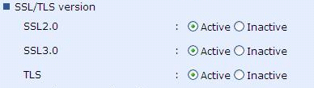

Support for certificate signing using an RSA key length of 2048 bits.

Support for RSA encryption with a key length of 2048 bits (used for SSL).

512 bits (md5WithRSA)

1024 bits (sha1WithRSA)

2048 bits (sha1WithRSA)

Support for 2048bit RSA was implemented in response to the NIST SP 800-131 recommendations.

The ability to enable/disable specific symmetric-key encryption algorithms/key lengths.

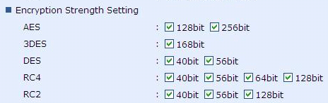

SNMP settings:

Web Image Monitor
To access the SNMP (v1/v2) settings, click Network > SNMP.
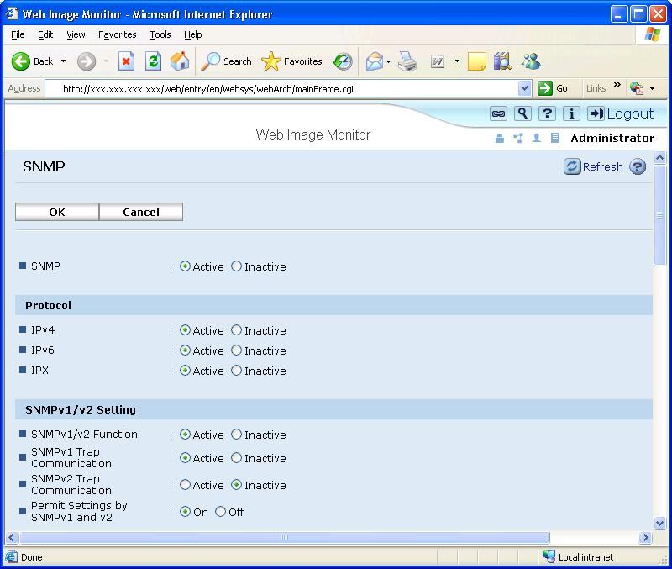

SNMP
(This setting can be configured either from here or from the SNMPv3 settings.)
Enable: Opens the SNMP port
Disable: Closes the port completely. No SNMP communication of any version can be used.
SNMP v1/v2 Function
Enable: Allows the use of SNMP v1/v2.
Disable: Does not allow connections using SNMP v1/v2. This is recommended because SNMP v1/v2 doesn’t have any mechanism for encryption or authentication, we recommend using ‘Disable’ for this setting unless absolutely necessary.
Permit Settings by SNMP v1 and v2
On: This enables SNMP set. It is used to write changes to settings.
Off: This disables SNMP set. Only get will be permitted. Therefore, settings can be read but not changed.
Network > SNMP v3
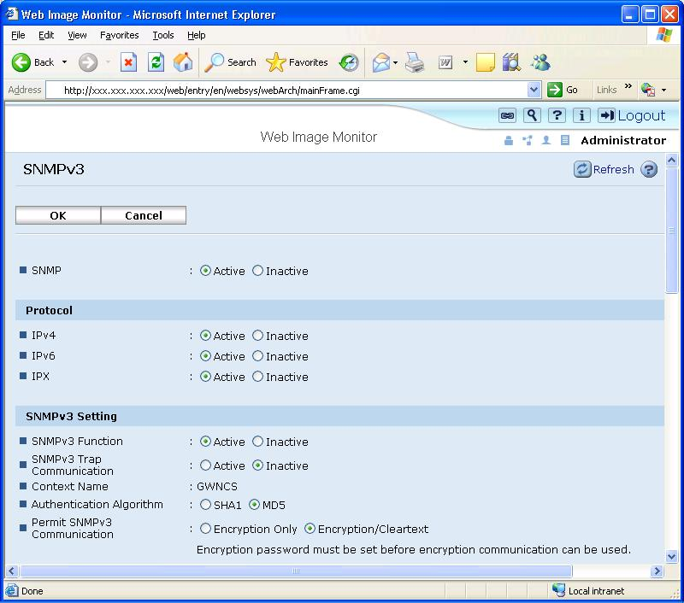

SNMP
(This setting can be configured either from here or from the SNMPv1/v2 settings.)
Enable: Opens the SNMP port
Disable: Closes the port completely. No SNMP communication of any version can be used.
SNMP v3 Function Enable: Allows communication using SNMP v3. Disable: Does not allow communication via SNMP v3.
Authentication Algorithm
SHA1: Hashes the username and password using the SHA1 hashing algorithm.
MD5: Hashes the username and password using the MD5 hashing algorithm.
Permit SNMPv3 communication
Encryption Only: The username and password must be encrypted using the hashing algorithm selected above.
Encryption/Clear Text: The username and password can be sent either encrypted or unencrypted.
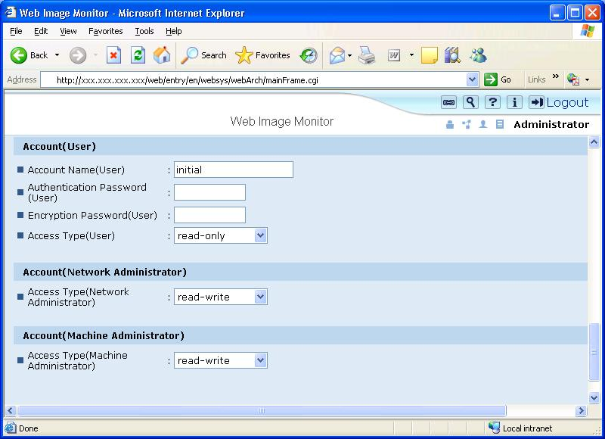

There are 3 different types of accounts that can be used for SNMPv3 connections. Only the User account can be fully configured here. For information about fully configuring the Machine and Network Administrator accounts, please refer to the Appendix section entitled “Administrator Account Settings”.
Account Name (User): This is the username that the user will use to login to SNMPv3.
Authentication Password (User): This is the password that the user will use to login to SNMPv3.
Encryption Password (User): This is the key used for SHA1 or MD5 hashing of the username and password.

mshell
(1) You can configure SNMP settings using snmp commands from mshell. These commands can be displayed by typing ‘help snmp’ in mshell.
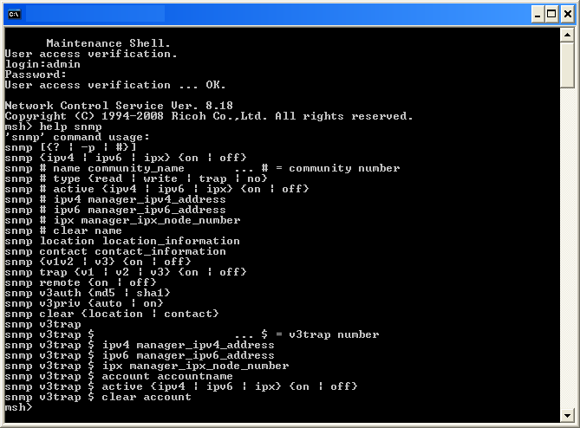

Administrator Account Settings

Web Image Monitor
Device Settings > Program/Change Administrator
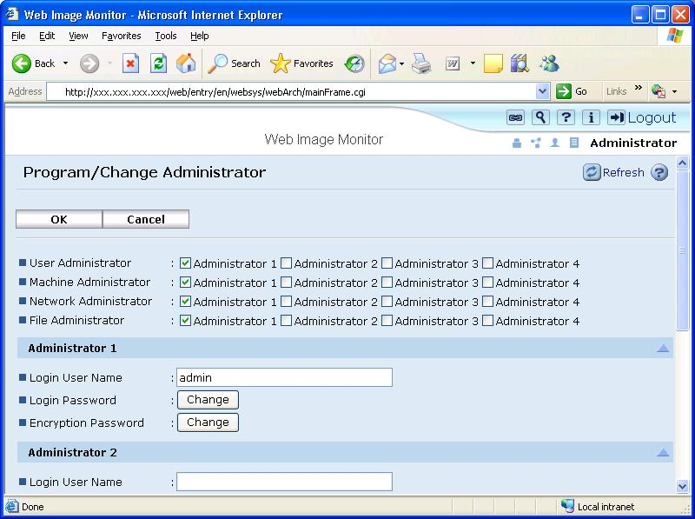

MFP Administrator account settings can be changed from here. Administrator roles can be assigned to any or all of up to 4 Administrators.
These settings affect the Administrator logins for TELNET, Web Image Monitor and SNMP v3.
Network Security Level settings

Configuration
Network Security Levels are settings-profiles designed to meet different levels of security in customer environments. The advantage to the Network Security Level settings is that they make the task of configuration easier. Customers can use the Network Security levels as is, or modify them to suit their needs. There are 3 levels to choose from:

[Level 2] – maximum security.
[Level 1] – moderate security for use in an office LAN.
[Level 0] – basic security for closed environments.
[User Settings] – manually defined settings.

To access the Network Security Level setting, click ‘Security’ -> ‘Network Security’.
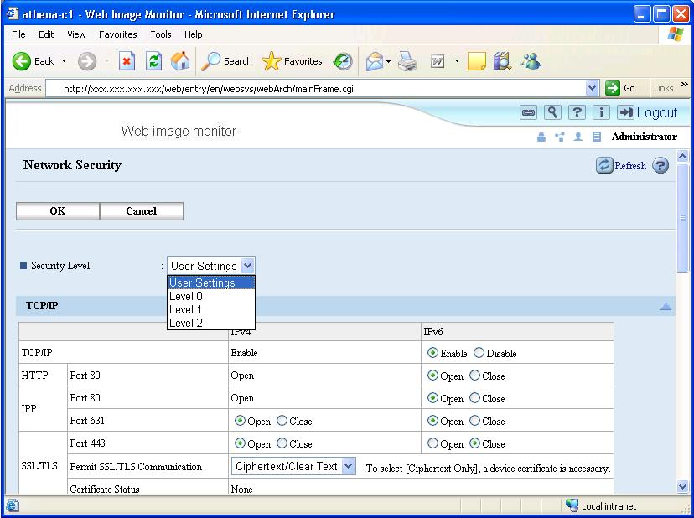

Description of the Levels
 | Setting |  | Network Security Level
 |  |  | Level 0 | Level 1 | Level 2
Interface | IEEE 1394 SBP-2 |  | Enabled | Enabled | Disabled
Interface | Bluetooth |  | Enabled | Enabled | Disabled
Interface | IP over 1394 |  | Enabled | Enabled | Enabled
TCP/IP | TCP/IP |  | Enabled | Enabled | Enabled
TCP/IP | HTTP/HTTPS | Port 80 | Port open | Port open | Port open*1
TCP/IP | HTTP/HTTPS | Port 443 | Port open | Port open | Port open
TCP/IP | HTTP/HTTPS | Port 7443/7444 | Port open | Port open | Port open
TCP/IP | IPP | Port 80 | Port open | Port open | Port open *1
TCP/IP | IPP | Port 443 | Port open | Port open | Port open
TCP/IP | IPP | Port 631 | Port open | Port open | Port closed
TCP/IP | SSL | Encryption Mode | Ciphertext Priority | Ciphertext Priority | Ciphertext Only *2
TCP/IP | DIPRINT | Port 9100 | Port open | Port open | Port closed
TCP/IP | LPR | Port 515 | Port open | Port open | Port closed
TCP/IP | FTP | Port 21 | Port open | Port open | Port open
TCP/IP | SSH/SFTP | Port 22 | Port open | Port open | Port open
TCP/IP | RFU | Port 10021 | Port open | Port open | Port open
TCP/IP | RSH/RCP | Port 514 | Port open | Port open | Port closed
TCP/IP | SNMP | Port | Port open | Port open | Port open
TCP/IP | SNMP | SNMP v1/v2 (Read) | Enabled | Enabled | Disabled
TCP/IP | SNMP | SNMP v1/v2 (Write) | Enabled | Disable | Disabled
TCP/IP | SNMP | SNMP v3 | Enabled | Enabled | Enabled
TCP/IP | SNMP | SNMP v3 with Encrypt | Automatic | Automatic | Ciphertext Only
TCP/IP | TELNET | Port 23 | Port open | Port closed | Port closed
TCP/IP | SSDP (UPnP) | Port 1900 | Port open | Port open | Port closed
TCP/IP | mDNS | Port 5353 | Port open | Port open | Port closed
TCP/IP | NBT | Port 137/138 | Port open | Port open | Port closed
TCP/IP | SMB | Port 139 | Port open | Port open | Port closed
TCP/IP | WS-Device | Port 3702/53000 | Port open | Port open | Port closed
TCP/IP | WS-Printer  WS-Scanner | Port 53001  Port 53002 | Port open | Port open | Port closed
TCP/IP | RHPP | Port 59100 | Port open | Port open | Port closed
TCP/IP | IPDS | Port 5001 | Port open | Port open | Port closed
Netware | Netware |  | Enabled | Enabled | Disabled
AppleTalk | AppleTalk |  | Enabled | Enabled | Disabled
*1: The port is open but cannot be used to access the web service because the SSL setting is Ciphertext Only.
*2: If the SSL setting is Ciphertext Only, the products will still accept IPP jobs using port 80.

Wireless LAN settings
WEP, WPA-PSK/WPA2-PSK, and WPA (802.1X)/WPA2 (802.1X) can be configured via the operation panel, telnet, or Web Image Monitor. However, the WPA (802.1X)/WPA2 (802.1X) certificate settings can only be configured in Web Image Monitor.

Web Image Monitor
Click ‘Interface’ -> ‘Wireless LAN Settings’.
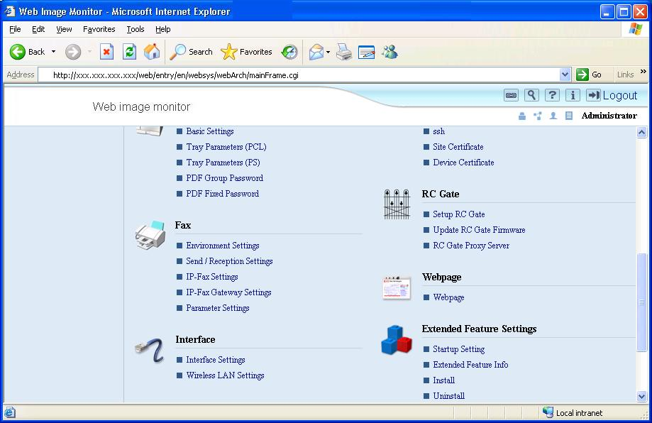

Change Interface Ethernet: Enable Ethernet IEEE802.11b: Enable IEEE802.11b

[IEEE802.11b Settings]
Network Enable: IEEE802.11b is enabled Disable: IEEE802.11b is disabled
MAC Address
Displays the MAC Address of the Wireless LAN board.

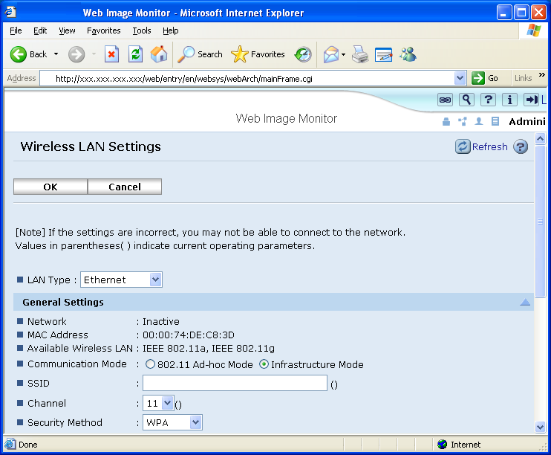
Communication Mode
802.11 Ad-hoc Mode: Ad-hoc connection using SSID.
Infrastructure Mode: Communicates using an access point and SSID.

Channel
Sets the radio frequency used. If Infrastructure mode is being used, this setting is unimportant as the channel defined by the access point will be used automatically.
Security Method
Inactive: No encryption of data.
WEP: Uses WEP security.
WPA: Uses WPA security.

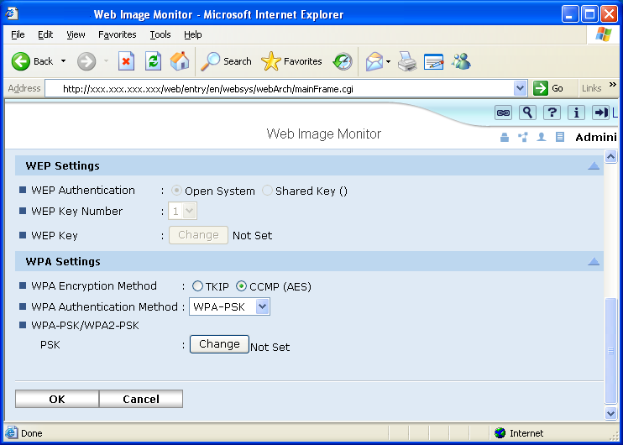
WEP
WEP settings can only be configured if ‘WEP’ is selected in ‘IEEE802.11b Settings’ -> ‘Security Type’.
WEP Authentication
Open System: Anyone with the correct SSID can join the network.
Note: As the system uses a WEP key, simply joining the network is not enough to be able to receive or send readable communications.
Shared Key: WEP key required to join the network.

WEP key number
Up to 4 WEP keys can be saved in the MFP. Select one of them.
WEP Key
Set the WEP key used for WEP encryption. If 64-bit key is used, 10 hexadecimal characters or 5 alphanumeric characters need to be entered. If a 128-bit key is used, 26 hexadecimal characters or 13 alphanumeric characters need to be entered.
[WPA]
WPA settings can only be configured if ‘WPA’ is selected in ‘IEEE802.11b Settings’ -> ‘Security Type’.
WPA Encryption Method TKIP: Uses TKIP. CCMP: Uses CCMP.
WPA Authentication Method
WPA : Uses WPA (802.1X).
WPA2: Uses WPA2 (802.1X)
WPA-PSK: Uses WPA-PSK.
WPA2-PSK: Uses WPA2-PSK.

WPA-PSK/WPA2-PSK
PSK: Sets the pre-shared key used.

IEEE 802.1X(WPA/WPA2)
Security > IEEE 802.1X(WPA/WPA2)
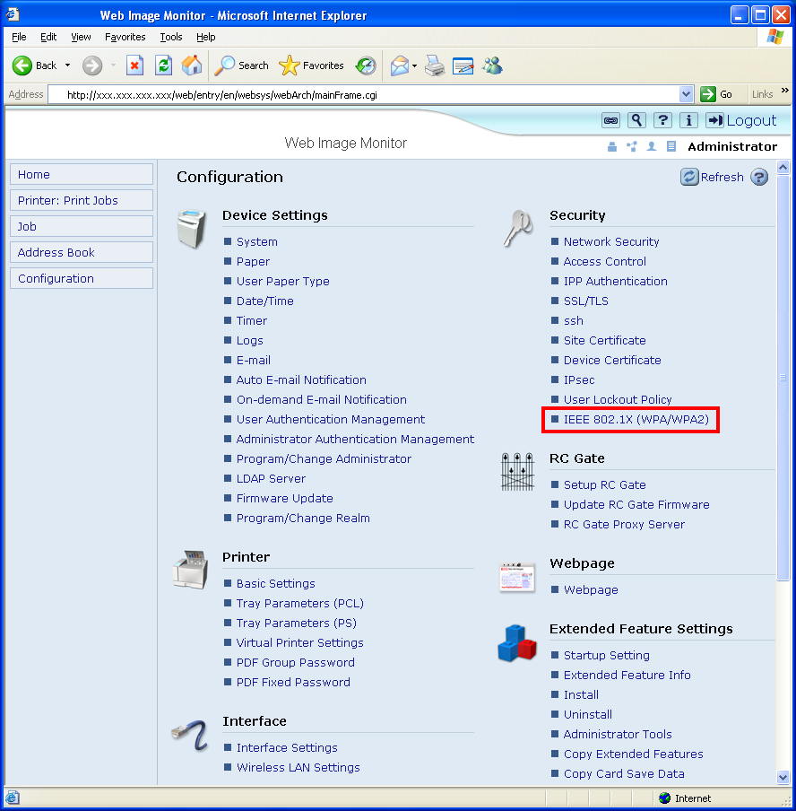
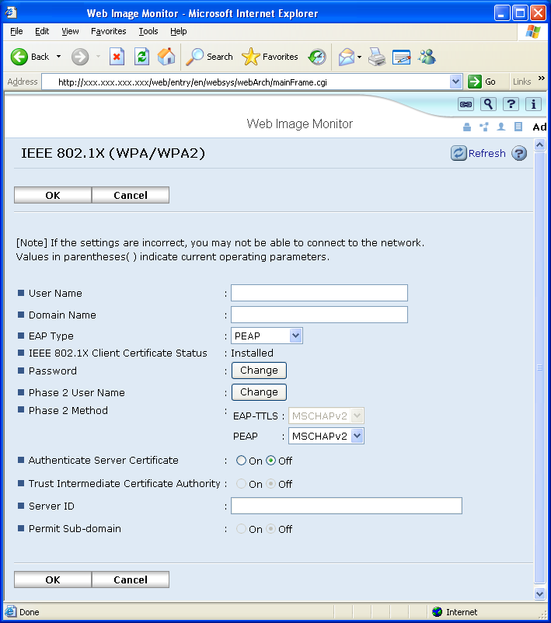

User Name: This is the username used for EAP authentication on the Radius server.
Domain Name: This is the domain name used for the authentication on the Radius server.
EAP Type: EAP-TLS, LEAP, EAP-TTLS, or PEAP
IEEE 802.1X Client Certificate Status: Displays the status of the device certificate specified for wireless LAN connection in [Certification] on the [Device Certificate] page(None, Requesting, Installed, Installed/Requesting)
Password: This is the password used for EAP authentication on the Radius server.
Phase 2 User Name: This is the user name used in phase 2 of EAP-TTLS and PEAP.
Phase 2 Methods (EAP-TTLS): If EAP-TTLS is selected as the EAP type, a Phase2 authentication method must be selected. Select from CHAP, MSCHAP, MSCHAPv2, PAP, or MD5
Phase 2 Methods (PEAP): If PEAP is selected as the EAP type, a Phase2 authentication method must be selected. Select from MSCHAPv2 or TLS.
Authentication Server Certificate: Select whether the Radius Server is required to send a certificate to connecting WPA (802.1x) client.
Trust Intermediate Certificate Authority: Select whether the certificate provided by the Radius Server must be signed by a trusted CA.
Server ID: This is the CN (or the DC) of server certificate.
Permit Sub-domain : Select whether the server certificate is permitted for the sub-domain of server ID.

mshell
Configure Wireless LAN settings using ‘wiconfig’ commands from mshell. For a list of commands, type ‘help wiconfig’ in mshell.
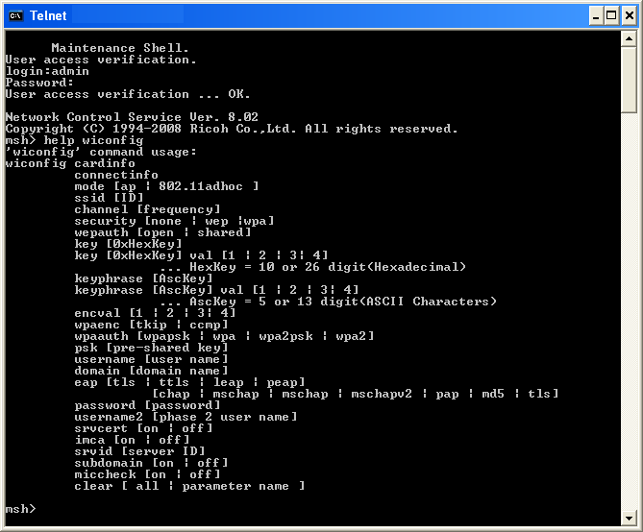

IPsec settings
IPsec settings can be configured via telnet, or Web Image Monitor. In order to establish IPsec connection In this section, we focus on MFP configuration only. Please refer to the client’s manual for information about configuring it..

Web Image Monitor
Security > IPsec
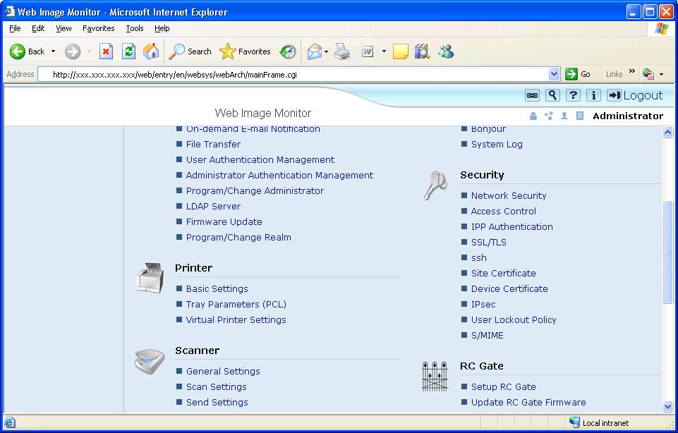

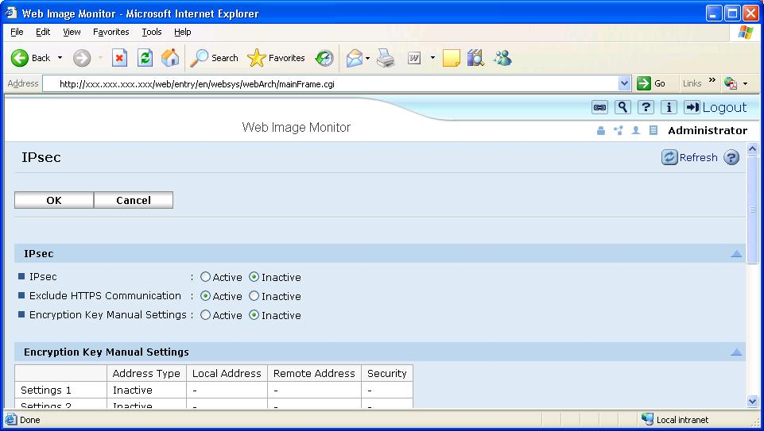

IPsec:
IPsec
Active: Activate IPsec
Inactive: Deactivate IPsec
Exclude HTTPS Communication
Active: Exclude HTTPS Communication for IPsec policy
Inactive: Do not exclude HTTPS communication for IPsec policy
Encryption Key Manual Settings
Active: When specifying SA parameters manually, select Active.
Inactive: When specifying SA parameters automatically, select Inactive

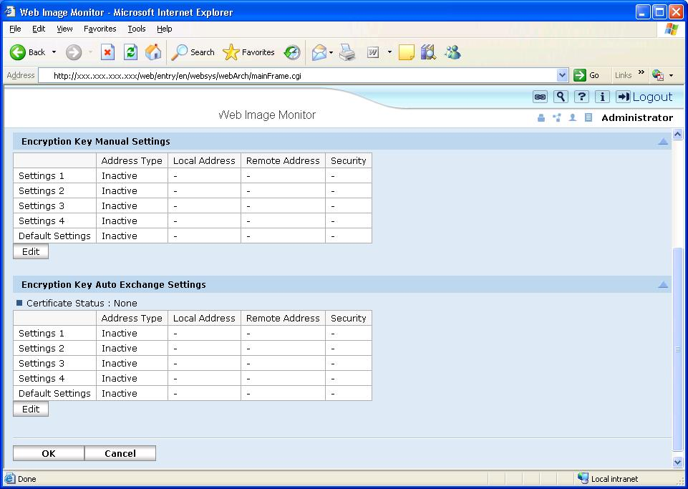

Encryption Key Manual Settings:
To configure IPsec SA parameters manually, click ‘Edit’.
Encryption Key Auto Exchange Settings:
To configure IPsec SA Parameters automatically, click ‘Edit’.
The Settings are listed in order of priority, top to bottom (‘Settings 1’, ‘Settings 2’ , ‘Settings 3’, ‘Settings 4’, ‘Default Settings’) The lowest number has the highest priority. ‘Default Settings’ has the lowest priority.

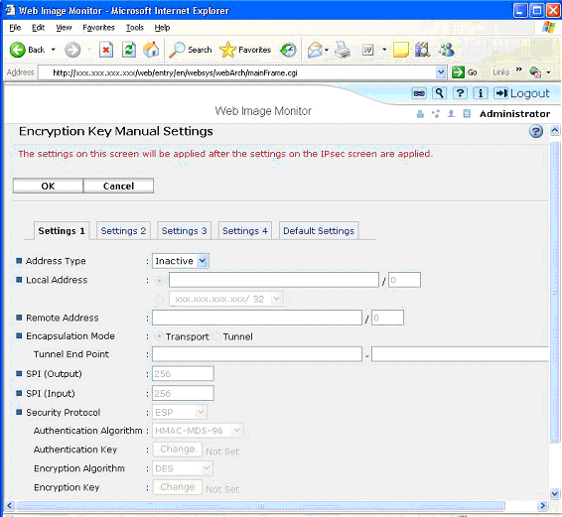
Encryption Key Manual Settings::
Address Type
Inactive: Do not use IPsec
IPv4: Apply IPsec for IPv4
IPv6: Apply IPsec for IPv6
IPv4/IPv6: Apply IPsec for IPv4 and IPv6 (Only available for ‘Default Settings’)
Local Address: Enter (Select) the product’s IP address.
Remote Address: Enter the counterpart’s IP address or address range.
Encapsulation Mode
Transport: IPsec is applied as Transport mode.
Tunnel : IPsec is applied as Tunnel mode. When Tunnel Mode is specified, Tunnel End Point has to be specified. In the left box, enter the product’s IP address. In the right box, enter the gateway IP address.
SPI (Output): Set the SPI value for outgoing SA connection. Any number between 256 and 4095
SPI (Input): Set the SPI value for incoming SA connection. Any number between 256 and 4095
Security Protocol
ESP: Uses ESP
AH: Uses AH
AH+ESP: Uses dual mode (AH + ESP)
Authentication Algorithm: Select from HMAC-MD5-96 or HMAC-SHA1-96 as hashing algorithm
Authentication Key: Set the Authentication key used for hashing. For HMAC-MD5-96, enter up to 32 in hexadecimal number, or up to 16 ASCII. For HMAC-SHA1-96, enter up to 40 in hexadecimal number, or up to 20 ASCII
Encryption Algorithm: Select from Clear Text, DES, 3DES, AES-128, AES-192, or AES-256.
Encryption Key: Set the encryption key. If AH is selected as security protocol, this is grayed out. For DES, enter up to 16 in hexadecimal number, or up to 8 ASCII. For 3DES, enter up to 48 in hexadecimal number, or up to 24 ASCII. For AES-128, enter up to 32 in hexadecimal number, or up to 16 ASCII. For AES-192, enter up to 48 in hexadecimal number, or up to 24 ASCII. For AES-256, enter up to 64 in hexadecimal number, or up to 32 ASCII.
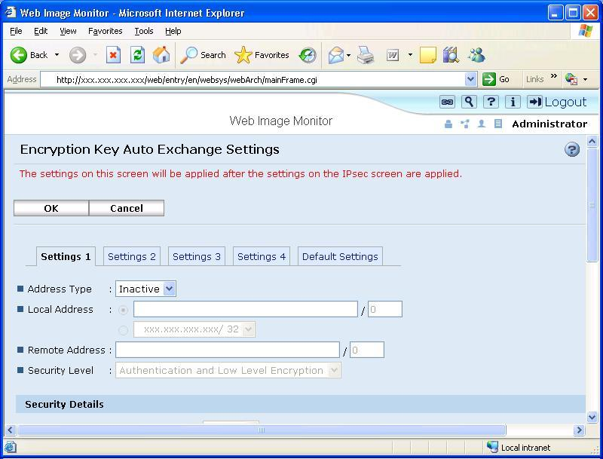
Encryption Key Auto Exchange Settings:
Address Type
Inactive: Do not use IPsec
IPv4: Apply IPsec for IPv4
IPv6: Apply IPsec for IPv6
IPv4/IPv6: Apply IPsec for IPv4 and IPv6 (Only available for ‘Default Settings’)
Local Address: Enter (Select) the product’s IP address.
Remote Address: Enter the counterpart’s IP address or address range.
Security Level: User can select the IPsec security level from followings. Depending on the selected security level, the parameters in below Security Details change.
Authentication Only
Authentication and Low Level Encryption
Authentication and High Level Encryption
User Settings

Security Details:
Security Policy
Apply: Apply IPsec
Bypass : Do not apply IPsec. All data is sent as plain text.
Discard: All data is discarded.
Encapsulation Mode
Transport: IPsec is applied as Transport mode.
Tunnel : IPsec is applied as Tunnel mode. When Tunnel Mode is specified, Tunnel End Point has to be specified. In the left box, enter the product’s IP address. In the right box, enter the gateway IP address.
IPsec Requirement Level
Use When Possible: Allows the cleartext transmission when IPsec cannot be established.
Always Require: Allows only the IPsec transmission.
Authentication Method
PSK: Use pre-shared key as authentication method. If PSK is selected, the pre-shared key has to be entered up to 32 alphanumeric number.
Certificate: Use certificate for authentication.
Phase 1:
Hash Algorithm: MD5 or SHA1
Encryption Algorithm: DES or 3DES
Diffie-Hellman Group : Select the Diffie-Hellman Group from 1, 2, or 14
Validity Period : Enter the number between 300 and 172800 seconds.

Phase 2:
Security Protocol
ESP: Uses ESP
AH: Uses AH
AH+ESP: Uses dual mode (AH + ESP)
Authentication Algorithm: Select from HMAC-MD5-96 and HMAC-SHA1-96.
Encryption Algorithm Permissions: Select from Cleartext, DES, 3DES, AES-128, AES-192, and AES-256.
PFS
Inactive: Do not generate the encryption or authentication keys again.
1, 2, or 14: Diffie-Hellman Group for establishing IPsec SA in Phase 2.
Validity Period : Enter the number between 300 and 172800 seconds.

mshell
Configure IPsec settings using ‘ipsec’ commands from mshell. For a list of commands, type ‘help ipsec’ in mshell.
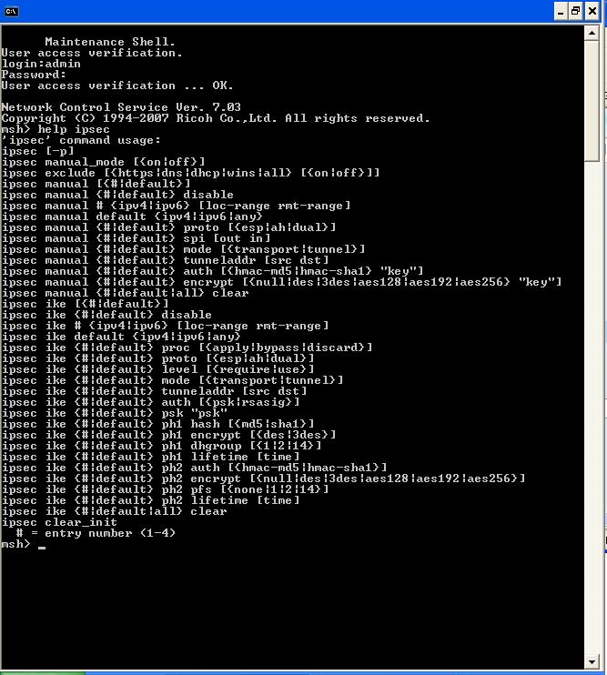

Reference list
- RFC: HTTP://www.faqs.org/rfcs/
- CVE: HTTP://cve.mitre.org/
- CERT: HTTP://www.cert.org/
- CIAC: HTTP://www.ciac.org/ciac/
- Security Focus: HTTP://www.securityfocus.com/
- NESSUS: HTTP://www.nessus.org/index2.html

