Issued: March 6, 2007


Network Security White Paper

ver.E.1.2
Covered Products:
Model S-C3

Model K-C3
Model G-P2
Model A-P4

Model AP-P1
Model MT-P2
Model AT-C1
Model AP-C1
Model MT-C3
Model B-C3
Model PG-C1
Notice
This document May not be reproduced or distRibuted in whole or in part, for any purpose or in any fashion without the prior written consent of Ricoh Company limited. Ricoh Company limited retains the sole discretion to grant or deny consent to any person or party.

Copyright © 2006 by Ricoh Company Ltd.

All product names, domain names or product illustrations, including desktop images, used in this document are trademarks, registered trademarks or the property of their respective companies. They are used throughout this book in an informational or editorial fashion only. Ricoh Company, Ltd. does not grant or intend to grant hereby any right to such trademarks or property to any third parties. The use of any trade name or web site is not intended to convey endorsement or any other affiliation with Ricoh products.

Although best efforts were made to prepare this document, Ricoh Company Limited makes no representation or warranties of any kind with regards to the completeness or accuracy of the contents and accepts no liability of any kind including but not limited to performance, merchantability, fitness for any particular purpose, or any losses or damages of any kind caused or alleged to be caused directly or indirectly from this document.

T
Version history
Version | Issue Date | Revised item
E.1.0 | Aug. 2, 2006 | Initial release
E.1.1 | Dec. 26, 2006 | 06 spring models are added.
E.1.2 | Mar. 6, 2007 | Model K-C3, S-C3 are added.

The following terms are used in this document. Please familiarize yourself with them.
Terms:
the products: This refers to the digital multifunction and printing devices covered by this document, as noted in the Model Cross Reference table. “the products” refers to all of these machines collectively.
Host Interface: The physical interface of the Ethernet board on the products.

Model Cross Reference:
cc | Product  Code | Brand
cc | Product  Code | Ricoh | Savin | Gestetner | Lanier | NRG | infotec
Model AT-C1 | B230  B237 | Aficio MP C2500  Aficio MP C3000 | C2525  C3030 | MPC2500/DSc525  MPC3000/DSc530 | MP C2500/LD425c  MP C3000/LD430c | MP C2500  MP C3000 | ISC 2525  ISC 3030
Model AP-C1 | B222  B224 | Aficio MP C3500  Aficio MP C4500 | C3535  C4540 | MPC3500/DSc535  MPC4000/DSc545 | MP C3500/LD435c  MP C4500/LD445c | MP C3500  MP C4500 | ISC 3535  ISC 4045
Model MT-C3 | B246  B248  B249 | Aficio MP 5500  Aficio MP 6500  Aficio MP 7500 | 8055  8065  8075 | MP5500/DSm755  MP6500/DSm765  MP7500/DSm775 | MP C5500/LD255  MP C6500/LD265  MP C7500/LD275 | MP 5500  MP 6500  MP 7500 | IS 2255  IS 2265  IS 2275
Model B-C3 | B234  B235  B236 | Aficio MP 9000  Aficio MP 1100  Aficio MP 1350 | 8090  8110  8135 | MP9000/DSm790  MP1100/DSm7110  MP1350/DSm7135 | MP 9000/LD190  MP 1100/LD1110  MP 1350/LD1135 | MP 9000  MP 1100  MP 1350 | IS 3090  IS 3110  IS 3135
Model PG-C1 | B229 | Aficio MP C1500sp/615c | SGC 1506 | MPC1500/GS106 | MPC1500/LD215c | MP C1500sp | ISC 615G
Model G-P2 | G160  G161 | Aficio SP C410DN  Aficio SP C411DN | CLP27DN  CLP31DN | SP C410DN / C7526dn  SP C411DN / C7531dn | SP C410DN / LP226cn  SP C411DN / LP231cn | SP C410DN  SP C411DN | IPC 2525DN  IPC 3030DN
Model A-P4 | G147 | Aficio SP 8100DN | MLP1 45 | SP 8100DN / GP7245 | SP 8100DN / LP145n | SP 8100DN | -
Model AP-P1 | G133 | Aficio SP C811DN | CLP240D | SP C811DN / C7640nD | SP C811DN / LP440c | SP C811DN | IPC 4040DN
Model MT-P2 | G148 | Aficio SP 9100DN | MLP175n | SP 9100DN / P7675 | SP 9100DN / LP275hdn | SP 9100DN | -

cc | Product  Code | Brand
cc | Product  Code | Ricoh | Savin | Gestetner | Lanier | NRG | infotec
Model S-C3 | B262 / B292  B284  B288 | Aficio MP 161  Aficio MP 161F  Aficio MP 161SPF | 816  816f  816mf | DSm416 / MP 161  DSm416f / MP 161F  DSm416pf/ MP161SPF | LD016 / MP161  LD016f / MP161 F  LD016spf / MP161SPF | MP161  MP161F  MP 161SPF | IS2416  IS2416F  IS2416FPS
Model K-C3 | B245  B276  B277 | Aficio MP 1500  Aficio MP 1600  Aficio MP 2000 | -  9016  9021d | DSm715 / MP1500  DSm716 / -  DSm721d / - | LD315 / MP 1500  LD316 / -  LD320 / - | MP 1500  -  - | IS 2315  IS 2316  IS 2320

Note: Parts of this document may not apply to some models. For example, printer models do not have scanners. Therefore some uses of RSH (for scanning) do not apply to these models.

Table of contents
- Introduction
- Port based network services and potential security issues
  - TELNET
  - FTP
  - HTTP
  - SNMP v1/v2
  - SHELL (RSH/RCP)
  - LPD
  - IPP
  - DIPRINT (RAW print)
  - SMB
  - MDNS
  - HTTPS
  - SNMP v3
  - H323hostcall/SIP
  - SSDP
  - SFTP (SSH)
  - Others
- Other Network Services
  - Wireless LAN
- Appendix
A) The list of services provided with open TCP/UDP ports
B) Related Protocols
C) The purpose of Access Control
C)-1. Web Image Monitor
C)-2. mshell
D) How to disable services
D)-1. Web Image Monitor
D)-2. mshell
E) HTTP/HTTPS settings
F) SNMP v1/v2/v3 settings
F)-1. Web Image Monitor
F)-2. mshell
G) How to change administrator account settings
H) Network Security Level settings
H)-1. How to configure
H)-2. Description of levels
I) Wireless LAN settings
I)-1. Wireless LAN – Web Image Monitor
I)-2. Wireless LAN – mshell

- Reference List
- Introduction

This document describes potential network threats and recommended precautions for them.
The products have built-in network services for providing a variety of features for wired and wireless network clients, such as network scanning, printing or faxing, and also client services for accessing network servers running outside the products, such as an LDAP server, Netware server, or Mail server.
This document focuses on how-to protect against potential threats from external attacks.

As the products are designed for use inside an Intranet where network clients and servers are protected by firewalls, the products rely on the Intranet’s security policy, like the security provided by other network servers and clients. However, some customers require more strict security levels for network devices, because potential threats from inside the firewalls are increasing, and some configurations even use a secure connection to the Internet as a part of the Intranet.
To satisfy these demands, the products are all evaluated by security scanning applications during development, and also are checked for known vulnerability issues reported by Internet security organizations, such as CERT Coordination Center (CERT/CC : HTTP:// www.cert.org/ ). Whenever we find security vulnerabilities in the products, we provide appropriate countermeasures.

- Port Based Network Services and Potential Security Issues

Some server services allow write access from network clients. Because of this, some customers may feel that the products are insecure against viruses, worms, or intruder accesses. The products are secure against such attacks and provide security measures against potential threats to specific services, but some of these measures can make the services unavailable. For example, disabling the LPD port will make the products unavailable for LPR clients.
You should disable all protocols that are not being used. This can be done more quickly using Network Security Levels (described in Appendix H). The Network Security Level function can be used to expedite security configuration. Please refer Appendix H for information about the configuration and a description of each level.

We also recommend using the Access Control function for added security. Access Control is a list of “safe” client host addresses. Once you set up Access Control for specific IP addresses, the products will receive print or scan requests from the specified hosts only. Access Control is applied for LPR printing, RSH/RCP access, HTTP/HTTPS access, FTP printing, TCP raw printing (DIPRINT), SMB printing, IPP printing, and scanning from DeskTopBinder. For information on how to set up access control, please refer Appendix C.

In the following sections, the potential threats and recommended precautions are given for each service. The recommended precautions should be accompanied by a firewall and restricted by Access Control.
2.1. TELNET
2.1.1. Function Overview
The TELNET service provides a virtual terminal service in order to use the maintenance shell (mshell). It is compliant with RFC 854. The mshell uses TCP port 23 and provides a dedicated command interface for the following functions.
- Configuring network settings of the products from remote terminals
- Monitoring device status and settings from remote terminals
- Getting system logs from remote terminals
Unlike shell services for UNIX/Linux, the mshell provides a command interface for configuration purposes only. Access to the file system or kernel, or modifying system files inside the products is not possible.
When logging into the mshell, the user must enter a correct username and password.

2.1.2 Potential threats
1) Destruction, corruption and modification of the file system and kernel.
There is no possibility of destruction, corruption or modification of the file system.
The mshell permits write-access to network parameters only and no one can access the file system or kernel.
2) Possibility of acting as a server for relaying viruses.
There is no possibility that the products will be used by viruses as an open relay server, because unrecognized data is disregarded. Also, neither the local file system nor remote host can be accessed via the mshell.
3) Theft of username and password
Interception of network packets: When accessing the products using TELNET, the username and password are sent in clear text, because the TELNET protocol itself does not support encryption. So if the username and password are intercepted by a packet sniffer, the possibility of unauthorized access and changes being made does exist.

2.1.3 Recommended precautions
The following are suggested precautions against threats to the embedded TELNET service.
The levels described below indicate the level of security (Level 1 is lowest). Please take the appropriate action for your security policy.
Level 1: Change the username and password from the default value to something difficult to guess and change it regularly. (Please refer Appendix G)
- The username and password are the same as those used for logging into Web Image Monitor in Administrator mode. So, changing the username and password for the mshell means changing them for Web Image Monitor’s Administrator mode.
Level 2: Close the TELNET port.
- The TELNET port can be completely closed using Web Image Monitor. When TELNET is disabled, the services provided by the mshell will not be available.
2.2. FTP
2.2.1. Function Overview
The FTP (File Transfer Protocol) service provides the function of receiving data with reliability and efficiency. This service is compliant with RFC 959. TCP port 20 is used for FTP-data service and TCP port 21 is used for FTP-control service. The FTP client must be compliant with RFC 959.
The following functions are provided by the FTP service.
- Receiving print jobs from FTP clients
- Providing the following files to FTP clients
File name | Description | Attribute
Syslog | System log information | Read-only
Install | Install Shell script | Read-only
Stat | Printer Status | Read-only
Prnlog | Print log information | Read-only
Info | Printer Information | Read-only
Help | Help | Read-only
Fax application files (hidden) | Fax job log information  Fax counter  Fax address book | SmartDeviceMonitor for Admin/Client is required to read/ manage these files.

- Receiving firmware files from remote clients.
RFU requires Machine administrator privileges. When Web Smart Device Monitor is used for RFU, TCP port 10020/10021 are used to send firmware files via the FTP protocol. However, port 21 is used to negotiate the transfer. All 3 ports must be open. It is a proprietary process defined by Ricoh and is extremely difficult to emulate without the knowledge of the specification. However if a strict security policy is to be maintained, that port can be closed via TELNET. (Please refer to Appendix C.)

2.2.2 Potential threats
1) Destruction, corruption and modification of the file system.
There is no possibility of destruction, corruption or modification of the file system.
Although the FTP service permits write-access, any files that are received by the printer are considered to be a print job or firmware data. When the embedded FTP server receives an executable file, the products prints a binary representation (garbage characters) of the data contained in the executable. As for firmware, a dedicated account and password that are disclosed only to Service Technicians is required to input firmware to the printer using the FTP service. In addition, data is verified by checking the header, IDs and the file format before being used. It is impossible to make a pseudo firmware file to destroy the file system.
2) Possibility of acting as a server for relaying viruses.
There is no possibility that the products will be used by a virus as an open relay server. Although the FTP service permits write-access, all written data are treated as print jobs. Even if someone sent an executable file via the embedded FTP service, the products print the file as garbage data.
4) Theft of username and password.
Interception of network packets: When accessing the products using FTP, the username and the password are sent in clear text because the FTP protocol itself does not support encryption. However, this does not present a major security risk because no changes can be made to the system via FTP. In fact a username and password are not even necessary when logging onto an FTP session except when for updating the firmware. When putting firmware data onto an FTP server, a dedicated account and password are required and they are disclosed to only Service Technicians. There is no possibility of destruction of the file system from someone using a sniffed username and password because it is impossible to make a pseudo firmware file to destroy the file system.
5) Theft of print data
Interception of network packets: Using FTP, print data is sent as clear text. If intercepted by a third party it is easily read.
2.2.3 Recommended precautions
As stated earlier, the suggested precaution against the threats to the embedded FTP service is closing the FTP port if you maintain a strict security policy. The port for this service can be completely closed using Web Image Monitor or the mshell.
Note1: To reduce the likelihood of print data being intercepted, please use SFTP instead of FTP as the printing protocol.
2.3. HTTP
2.3.1. Function Overview
The HTTP (Hypertext Transfer Protocol) service provides web services. This service is compliant with RFC 1945. TCP port 80 is used for the HTTP service.

The following functions are provided by the HTTP server service.
- Configuring machine settings via Web Image Monitor in Administrator mode
- Viewing machine settings and status via Web Image Monitor
- Managing files saved in the Document Server of the products via DeskTopBinder.
- Managing user information and retrieving counter information when using User Management Tool in SmartDeviceMonitor for Admin/Client
- Managing the Product’s address book when using Address Management Tool in SmartDeviceMonitor for Admin.
- Printing a job from an IPP client.
- Providing job status to an IPP client.

Note1: When logging into Web Image Monitor in Administrator mode, the user must enter the username and password. It is the same as the username and password used for the mshell.

2.3.2 Potential threats
1) Destruction, corruption and modification of the file system
There is no possibility of destruction, corruption or modification of the file system. Because no one can access the file system and executable files cannot be processed on the products web server.
2) Possibility of acting as a server for relaying viruses
There is no possibility that the products will be used by a virus as an open relay server. The web server was developed by Ricoh and does not allow any malicious and executable files to be processed.
3) Theft of username and password
Interception of network packets: When accessing Web Image Monitor, the password is sent with BASE64 encode. In this case, the password is not sent in clear text, but it is not particularly difficult to decode.
Therefore, if the password is intercepted using a packet sniffed and then decrypted, the possibility of unauthorized access and changing of network settings does exist.
4) Theft of print data
Interception of network packets: Using HTTP, print data is sent as clear text. If intercepted by a third party it is easily read.

2.3.3 Recommended precautions
The following are suggested precautions against threats to HTTP service. The levels described below indicate the level of security (Level 1 is lowest). Please take the appropriate action for your security policy.
Level 1: Change the username and password from the default value to something difficult to guess and change them regularly.
- The username and password are the same as those used for logging in to the shell. So, changing the username and password for Web Image Monitor’s Administrator mode means changing them for the mshell as well.
Level 2: Forward HTTP requests to HTTPS.
- Whether all, some or none of the HTTP requests received by the MFP are forwarded to HTTPS, depends on the settings. (Please refer to Appendix E.)
Level 3a: Close the HTTP port.
- The HTTP port can be completely closed with mshell. In this case, both Web Image Monitor and IPP (Internet Print Protocol) are unavailable via HTTP. IPP printing provides printer access via HTTP (HTTP://<printer host name or IP address>/printer (or ipp)). If the HTTP port is closed, Web Image Monitor and IPP printing are still available via HTTPS.
Level 3b: Disable web function.
- If it is not needed, Web Image Monitor can be disabled using the mshell. When web is set to ‘Down’, Web Image Monitor does not activate and the error “503 Service Unavailable” is displayed. Even when not in use, TCP port 80 stays open and is therefore HTTP is available for IPP printing.

Note1: We recommend using HTTPS instead of HTTP for Web Image Monitor and IPP printing.
Note2: If you want to reduce the possibility of print data being intercepted, please use HTTPS instead of HTTP as the printing protocol.
2.4. SNMP v1/v2
2.4.1. Function Overview
SNMP (Simple Network Management Protocol) is used to communicate management information between the network management stations (SNMP manager), such as a PC running a management application, and the agents in the network (SNMP agent), such as printers, scanners, workstations or servers, routers and hubs. The SNMP service is embedded in the products, to provide a method of managing them on the network. This service is compliant with RFC 1157 for SNMP v1 and RFC 1902 for SNMP v2. UDP port 161 is used for SNMP service and UDP port 162 is used for SNMP-trap.
The following functions are available.
- Configuring the settings of the products.
- Monitoring the status of the products.
- Detecting errors affecting the products.
- Communicating with the client PC for Scanning using the TWAIN driver.
Although the SNMP service is not protected by a password, it is protected using unique community names and assigned access rights (read-only, read-write and trap) within those communities. You can only communicate with or configure an agent if it is a member of the same community and if the access rights allow you to get or modify data in the MIBs (Management Information Base) embedded in the products.
Default settings of SNMP community names are follows;
- Read-only: public
- Read-Write: admin

2.4.2. Potential threats and recommended precautions
1) Destruction, corruption and modification of the file system
There is no possibility of destruction, corruption or modification of the file system.
SNMP permits write-access to network parameters only and no one can access the file system or kernel.
2) Theft of community name
Interception of network packets: Community names are sent in clear text because of the specification of the protocol. Therefore, if intercepted, the community name is easily read.
3) Possibility of unauthorized parties intercepting device information:
Interception of network packets: The products do not respond with important information such as administrator password even if the SNMP client sends a get request for this information. Therefore security risk is low. However when accessing the products using SNMP, other parameters are sent in clear text. Because the SNMP v1/v2 protocol itself does not support encryption. So if other parameters are intercepted, there is a possibility of unauthorized parties obtaining device information.

2.4.3. Recommended precautions
The suggested precautions against this threat are as follows. The levels described below indicate the level of security (Level 1 is lowest). Please take the appropriate action for your security policy.
Level 1: Change the community names from the default value to something difficult to guess and change it regularly.
- When the community name settings are changed in the agents, the community name settings in the management utilities must also be changed.
Level 2: Change the setting so that only ‘get’ access using SNMP v1/v2 is allowed (disable ‘set’ access from SNMP v1/v2).
Level 3: Disable the SNMP v1/v2 service
- If it is not absolutely necessary, the SNMP service should be disabled via Web Image Monitor or the mshell.
Level 4: Close the SNMP port
- If it is not absolutely necessary, the SNMP port should be closed via Web Image Monitor or the mshell.
Note1: Please refer Appendix F for details about SNMP settings
Note2: We recommend using the maximum level of security possible. SNMP v3 should always be used in cases where SNMP v1/v2 is not absolutely necessary. Utilities that do not support SNMP v3 will not be able to get device status unless SNMP v1/v2 is enabled. Therefore these utilities will not work correctly if SNMP v1/v2 has been disabled. If your utility does not support SNMP v3 and only requires ‘get’ access to work (doesn’t make any changes to MFP settings), then we recommend security Level 2.
2.5. SHELL (RSH/RCP)
2.5.1. Function Overview
Remote shell (RSH/RCP) services provide the following functions via TCP port 514.
- Printing jobs from RSH/RCP clients.
- Monitoring machine status and settings from RSH/RCP clients.
- Providing the print logs and the system logs to RSH/RCP clients.
- Transferring scan data to the Twain driver.

2.5.2. Potential threats and recommended precautions
1) Destruction, corruption and modification of the file system
There is no possibility of destruction, corruption or modification of the file system. Because no one can access the file system or kernel and executable files cannot be processed via the remote shell service
2) Possibility of acting as a server for relaying viruses
There is no possibility that the products will be used by a virus as an open relay server. Although the remote shell service permits write-access, all written data are treated as print jobs. Even if someone sent an executable file via the embedded remote shell service, the products print the file as garbage data.
3) Theft of username and password
Interception of network packets: The RSH protocol has an authentication function. However an account is not necessarily needed to access products via RSH. If the user is concerned about this, the port for remote shell service can be completely closed via Web Image Monitor and mshell.
5) Theft of print data
Interception of network packets: Using RSH/RCP, print data is sent as clear text. If intercepted by a third party it is easily read.

2.5.3. Recommended precautions
As stated above, there are not many threats that apply to the products. However, if you want to maintain a strict security policy, the RSH/RCP service can be disabled and the port for this service can be completely closed using Web Image Monitor or the mshell.
Note1: If you want to reduce the possibility of print data being intercepted, please use HTTPS instead of RSH/RCP as the printing protocol.

2.6. LPD
2.6.1. Function Overview
The LPD service is one of the TCP/IP Printing Services known as LPD or LPR. This service is compliant with RFC 1179 and uses TCP port 515 for connection with a RFC 1179 compliant client. The following functions are provided by this service.
- Printing a job from LPR clients
- Monitoring the status of the printer and print queues from LPR clients.
- Deleting print jobs from the print queue by LPR clients.

2.6.2. Potential threats and recommended precaution
1) Possibility of acting as a server for relaying viruses
There is no possibility that the products will be used by a virus as an open relay server. The LPD service treats all received data as print jobs. Even if someone sends an executable file via the embedded LPD service, the products print the file as garbage data.
2) Possibility of successful DoS (Denial of Service) attacks.
There is no possibility of successful DoS attacks.
When the products receive the data that does not meet the protocol specification, the products will stop the LPD service, and the executed application (if any), at regular steps.
3) Theft of username and password
Interception of network packets: LPD does not have an authentication function. However, print data may contain authentication information. This information can be encrypted by the printer driver. Please refer the user manual and driver help for more information about this method.
4) Theft of print data
Interception of network packets: Using LPR, print data is sent as clear text. If intercepted by a third party it is easily read.

2.6.3. Recommended precaution
As stated above, there are not many threats that apply to the products. However, if a strict security policy is to be maintained, the LPD service can be disabled and the port for this service can be completely closed using Web Image Monitor or the mshell.
Note1: If you want to reduce the possibility of print data being intercepted, please use HTTPS instead of LPR as the printing protocol.
2.7. IPP
2.7.1. Function Overview
The IPP (Internet Printing Protocol) service is used for Internet printing from IPP clients. This service is compliant with RFC 2565 and it uses TCP port 631.
The following functions are provided by the IPP service.
- Printing a job from an IPP client.
- Providing job status to an IPP client.

The IPP service has a user authentication function. 10 accounts are available for IPP service and the password can be set for each account. Both “BASIC” and “DIGEST” authentication are supported. “BASIC” authentication is common, but the username and password are sent in clear text. “DIGEST” authentication is more secure with the username and password irreversibly hashed and the popularity of “DIGEST” authentication had been increasing at the time of this writing.
Both authentication methods are selectable in Web Image Monitor and mshell.
IPP authentication can also be disabled. In this case, usernames and passwords are not authenticated (The default setting is “disabled”.).

2.7.2. Potential threats and recommended precaution
1) Possibility of acting as a server for relaying viruses
There is no possibility that the products will be used by a virus as an open relay server. The IPP service treats all received data as print jobs. Even if someone sends an executable file via the embedded IPP service, the products print the file as garbage data.
2) Possibility of successful DoS (Denial of Service) attacks
There is no possibility of successful DoS attacks.
When the products receive data that can carry out a DoS attack, a waiting period is implemented in the reply process of the products. This reduces the system load and stops the service and application at regular steps if data that falls outside of the specification of the protocol is present in the system.
3) Theft of username and password
Interception of network packets: When the client negotiates the connection with the MFP, the MFP can specify whether the connection uses digest-MD5 hashing for the username and password.
4) Theft of print data
Interception of network packets: Using IPP, print data is sent as clear text. If intercepted by a third party it is easily read.

2.7.3. Recommended precaution
As stated above, there are not many threats that apply to the products. However, if you want to maintain a strict security policy, we recommend the following precautions. The levels described below indicate the level of security (Level 1 is lowest). Please take the appropriate action for your security policy.
Level 1: Set IPP Authentication to either “BASIC” or “DIGEST” from “Disabled” in Web Image Monitor, the mshell or the operation panel.
- “DIGEST” authentication is more secure than “BASIC” because the username and the password are not sent in clear text.
Level 2: Close the IPP (631/TCP) port.
- If it is not absolutely necessary, the IPP port should be closed via Web Image Monitor or the mshell.

Note1: This only closes the IPP port. The IPP service is still available using HTTP or HTTPS.
Note2: If you want to reduce the possibility of print data being intercepted, please use HTTPS instead of IPP as the printing protocol.

2.8. DIPRINT (RAW print)
2.8.1. Function Overview
The DIPRINT (Direct Print or RAW Print) service is Ricoh Company Ltd’s name for port 9100 communication. This service provides direct printing from remote terminals using TCP port 9100.

2.8.2. Potential threats and recommended precaution
1) Possibility of acting as a server for relaying viruses
There is no possibility that the products will be used by a virus as an open relay server. The DIPRINT service treats all received data as print jobs. Even if someone sends an executable file via the embedded DIPRINT service, the products print the file as garbage data.
2) Theft of username and password
Interception of network packets: DIPRINT does not have an authentication function. However, print data may contain authentication information. This information can be encrypted by the printer driver. Please refer the user manual and driver help for more information about this method.
3) Theft of print data
Interception of network packets: Using DIPRINT, print data is sent as clear text. If intercepted by a third party in is easily read.

2.8.3. Recommended precaution
As stated above, there are not many threats that apply to the products. However, if you want to maintain a strict security policy, the DIPRINT port can be changed and the port for this service can be completely closed using Web Image Monitor or the mshell.
Note1: If you want to reduce the possibility of print data being intercepted, please use HTTPS instead of DIPRINT as the printing protocol.

2.9. SMB
2.9.1. Function Overview
The SMB service uses NBT (NetBIOS over TCP/IP) as its base layer.
The NBT service provides the NetBIOS service over TCP/IP instead of NetBEUI. Using this service, a remote host can access network services of the products by the NetBIOS name (Computer Name) instead of IP address. This service uses 3 ports, UDP port 137 for NetBIOS-NS (NetBIOS Name Service), UDP port 138 for NetBIOS-DGM (NetBIOS Datagram Service) and TCP port 139 for NetBIOS-SSN (NetBIOS Session Service). SMB (Server Message Block) over TCP/IP is provided by this service as follows.
- Browsing the print servers from SMB clients
- Printing a job from SMB clients
- Sending job queue information to SMB clients
- Sending notifications of a job completion to SMB clients

2.9.2. Potential threats and recommended precautions
1) Possibility of acting as a server for relaying viruses
There is no possibility that the products will be used by a virus as an open relay server. The
SMB service treats all received data as print jobs. Even if someone sends an executable file via the embedded SMB service, the products print the file as garbage data.
2) Possibility of successful DoS (Denial of Service) attacks
There is no possibility of successful DoS (Denial of Service) attacks. Repeated access and disconnection to TCP port 139 is a well known DoS (Denial of Service) attack. The products are protected against this by accepting connections sequentially. And also when the products receive data that can be used to carry out a DoS attack, the connection with the sender will be disconnected.
3) Theft of username and password
Interception of network packets: The SMB protocol has an authentication function. However the products can be accessed using a guest account. All data received via SMB will simply be printed. Therefore this does not present a major security risk because no changes can be made to the system via SMB. However some print data may contain authentication information. The password can be encrypted by enabling the printer driver’s encryption function before sending data to the MFP. Please refer to the user manual and driver help for more information about this function.
4) Theft of print data
Interception of network packets: Using SMB, print data is sent as clear text. If intercepted by a third party in is easily read.
5) Possibility products being seen on the network by unauthorized parties via browsing (i.e. via network neighborhood).
To protect the products from being browsed by unauthorized parties, NetBIOS-NS and NetBIOS-DGM services should be disabled using the mshell.

2.9.3. Recommended precaution
The suggested precautions against this threat are as follows. The levels described below indicate the level of security (Level 1 is lowest). Please take the appropriate action for your security policy.
Level 1: Disable NetBIOS-NS and NetBIOS-DGM services using mshell
- If these services are disabled, the products will not be visible to anyone when the network is browsed (i.e. Via network neighborhood).
Level 2: Disable the SMB service
- If it is not absolutely necessary, the SMB service should be disabled via Web Image Monitor or the mshell.

Note1: If you want to reduce the possibility of print data being intercepted, please use HTTPS instead of SMB as the printing protocol.
2.10. MDNS
2.10.1. Function Overview
MDNS (Multicast DNS) is a way of using familiar DNS programming interfaces, packet formats and operating semantics, in a small network where no conventional DNS server has been installed.
The products only use MDNS for rendezvous. If rendezvous is not being used, this port can be closed.

2.10.2. Potential threats and recommended precaution
1) Possibility of unauthorized parties intercepting device information.
The products use MDNS to advertise services and device information.
If you do not want unauthorized parties to be aware of this information, the rendezvous service should be disabled using Web Image Monitor or the mshell.

2.10.3. Recommended precaution
As stated above, there are not many threats that apply to the products. However, if a strict security policy is to be maintained, the MDNS service can be disabled and the port for this service can be completely closed using Web Image Monitor or the mshell. (If rendezvous is turned off, the MDNS port is closed automatically.)

2.11. HTTPS
2.11.1. Function Overview
HTTPS is HTTP over SSL (Secure Socket Layer). HTTPS provides the same functions as HTTP. HTTPS maintains higher security than HTTP because SSL provides the following features:
- Server authentication/certification. (Protects against server spoofing.)
- Data Encryption. (Protects against wiretap/falsification.)

*About SSL
SSL is a communication technology used for secure connections between 2 hosts. The primary goal of the SSL Protocol is to provide privacy and reliability between two communicating applications. SSL is layered on top of some reliable transport protocol (e.g., TCP). SSL allows the server and client to authenticate each other and to negotiate an encryption algorithm and cryptographic keys before the application protocol transmits or receives its first byte of data.

2.11.2. Potential threats and recommended precaution
1) Destruction, corruption or modification of the file system
There is no possibility of destruction, corruption or modification of the file system. Because no one can access the file system and executable files cannot be processed on the products web server.
2) Possibility of acting as a server for relaying viruses
There is no possibility that the products will be used by a virus as an open relay server. The web server was developed by Ricoh and does not allow any malicious and executable files to be processed.
3) Theft of username and password
When using HTTPS, all data including the username and password is encrypted using SSL. This is safer than sending username and passwords encoded in Base 64 (using the HTTP).
4) Theft of print data
Interception of network packets: Using HTTPS, all data sent over the connection is encrypted. Therefore, even if data is intercepted, it will be extremely difficult for unauthorized parties to read.

2.11.3. Recommended precaution
The following are suggested precautions against threats to the HTTPS service. The levels described below indicate the level of security (Level 1 is lowest). Please take the appropriate action for your security policy.
Level 1: Change the user name and password from the default value to something difficult to guess and change them regularly.
- The username and password are the same as the one for logging in to the mshell. So, changing the username and password for Web Image Monitor’s Administrator mode means changing them for the mshell as well.
Level 2a: Close the HTTPS port.
- The HTTPS port can be completely closed with mshell. In this case, both Web Image Monitor and IPP (Internet Print Protocol) are unavailable via HTTPS. If the HTTPS port is closed, Web Image Monitor and IPP printing are still available via HTTP.
Level 2b: Disable web function.
- If it is not needed, Web Image Monitor can be disabled using the mshell. When web is set to ‘Down’, Web Image Monitor does not activate and the error “503 Service Unavailable” is displayed. Even when not in use, TCP port 443 stays open and is therefore HTTPS is available for IPP printing.

2.12. SNMP v3
2.12.1. Function Overview
SNMP v3 provides the same functions as SNMP. SNMP v3 maintains higher security than SNMP v1 and v2 because SNMP v3 has the following features:
- User Authentication
- Data Encryption

2.12.2. Potential threats and recommended precautions
1) Destruction, corruption and modification of the file system
There is no possibility of destruction, corruption or modification of the file system.
SNMP only permits write-access to network parameters. No one can access the file system or kernel.
2) Theft of username and password
Interception of network packets: When using SNMP v3, the password is hashed using SHA1 or MD5.
Brute force attack: To protect against brute force attempts at acquiring the SNMP password, the products limit the number of incorrect connection attempts to 100. After 100 attempts, the machine will enter a lockout mode that disables any incoming connection attempts for a specified length of time (60 seconds).
3) Possibility of unauthorized parties intercepting device information:
Interception of network packets: The products do not respond with important information such as administrator password even if the SNMP client sends a get request for this information. Therefore security risk is low. In addition the products encrypt other parameters.
(Please refer to Appendix F)

2.12.3. Recommended precaution
The suggested precautions against this threat are as follows. The levels described below indicate the level of security (Level 1 is lowest). Please take the appropriate action for your security policy.
Level 1: Change the usernames and password from the default value and the passwords for each user to something difficult to guess and change it regularly.
Level 2: Encrypt all data.
Level 3: Disable the SNMP v3 service.
- If it is not absolutely necessary, the SNMP v3 service should be disabled via Web Image Monitor or the mshell.
Level 4: Close the SNMP port.
- If it is not absolutely necessary, the SNMP port should be closed via Web Image Monitor or the mshell.

2.13. H323hostcall/SIP
2.13.1. Function Overview
H323/SIP services are used to provide VoIP (Voice over IP) for IP-Fax. The H.323 hostcall service is compliant with ITU-T standards and uses TCP port 1720. The SIP service is compliant with RFC3261 and uses TCP/UDP port 5060.

2.13.2. Potential threats and recommended precautions
1) Possibility of successful DoS (Denial of Service) attacks.
H323hostcall/SIP is only able to maintain a single session. In addition, session’s timeout if a recognizable response is not sent within a specified period. Therefore it is unlikely that the service could be stopped via DoS.
2) Theft of username and password
The SIP protocol supports the authentication function. However the products do not support authentication using the SIP protocol. Therefore the username and password are not included with data sent over this protocol.
3) Theft of facsimile data
Interception of network packets: Using IP-Fax, facsimile data is formatted for an ISDN connection and is not encrypted. If intercepted by a third party it can be read.

2.13.3. Recommended precaution
As stated above, there are not many threats that apply to H323hostcall/SIP. However, if a strict security policy is to be maintained, the TCP/UDP port numbers for H323hostcall (1720) and for SIP (5060) can be changed by a customer engineer. However, these services cannot be stopped.

2.14. SSDP

2.14.1. Function Overview
SSDP (Simple Service Discovery Protocol) is used for both advertising services and searching for services on UPnP network. SSDP uses UDP port 1900. If UPnP is not being used, this port can be closed.

2.14.2. Potential threats and recommended precautions

1) The possibility of unauthorized parties intercepting device information.
The products use SSDP to advertise services and search for services. If you do not want to unauthorized parties to be aware of this information, the SSDP service should be disabled using Web Image Monitor or the mshell.

2.14.3. Recommended precaution
If a strict security policy is to be maintained, the SSDP service can be disabled and the port for this service can be completely closed using Web Image Monitor or the mshell.

2.15. SFTP (SSH)
2.15.1 Function Overview
The SFTP (“Secure File Transfer Protocol” or “SSH File Transfer Protocol”) service provides the same functions as FTP. SFTP uses an SSH (Secure Shell) session over TCP port 22. The SSH provides the following features:
- Data Encryption. (Protects against interception/falsification).

*Abut SSH
SSH (Secure Shell) is a program to log into another computer over a network, to execute commands in a remote machine, and to move files from one machine to another. It provides strong authentication and secure communications over unsecured channels. It is intended as a replacement for rlogin, rsh, and rcp. Additionally, ssh provides secure X connections and secure forwarding of arbitrary TCP connections. Ricoh’s implementation of SSH is based on OpenSSH. For information about OpenSSH, please see:
http://www.openssh.com/

2.15.2 Potential threats
1) Destruction, corruption and modification of the file system or kernel:
There is no possibility of destruction, corruption or modification of the file system or kernel.
Although the SFTP service permits write-access, any files that are received by the printer are considered to be a print job or firmware data. When the embedded SFTP server receives an executable file, the products print a binary representation (garbage characters) of the data contained in the executable. As for firmware, a dedicated account and password is required to input firmware to the printer using the SFTP service. In addition, data is verified by checking the header, IDs and the file format before being applied as firmware.
2) Possibility of acting as a server for relaying viruses
There is no possibility that the products will be used by a virus as an open relay server. Although the SFTP service permits write-access, any data written to the device (executable or otherwise) is treated as a print job and output as ASCII data.
3) Theft of username, password, and device information
Using SFTP, all data including the username and password is encrypted using DES, 3DES or AES.
4) Theft of print data
Interception of network packets: Using SFTP, all data sent over the connection is encrypted. Therefore, even if data is intercepted, it will be difficult for unauthorized parties to read.

2.15.3 Recommended precaution
The following are suggested precautions against threats to the SFTP service. The levels described below indicate the level of security (Level 1 is lowest). Please take the appropriate action for your security policy.
Level 1: Change the username and password from the default value to something difficult to guess and change them regularly.
- The username and password are the same as those used for logging in to the shell.
Level 2: Close the SSH port.
- SFTP is used over TCP port 22. The SFTP port can be closed with mshell or WebImageMonitor. If closed, both printing and firmware updating are unavailable via SFTP.

2.16. Others
TCP port 7443 and 7444 are reserved for @Remote service. This service accepts only a Ricoh-confidential protocol and it is impossible to emulate it without knowledge of the protocol specification. In addition, we will not disclose the protocol specification to anyone outside of Ricoh Company, Ltd. As just described, there are no threats that apply to the products. However if a strict security policy is to be maintained, those ports can be closed via TELNET. (Please refer to Appendix C.)
HTTPS is used for this service as an underlying layer. Please refer to “2.11 HTTPS” for the potential threats and recommended precautions for HTTPS.

TCP port 12701 is reserved for internal use by the products itself. Access from the outside will be rejected.

3. Other Network Services
The Previous section dealt mainly with port based network services. This section will describe security related information for non-port based network services.

3.1. Wireless LAN
3.1.1. Overview
WLAN utilizes spread spectrum technology based on radio waves to enable communication between devices in a limited area. This gives users the mobility to move around within a broad coverage area and still be connected to the network. The absence of cables leaves transmissions extremely susceptible to interception. For this reason a variety of security precautions have been incorporated into WLAN specifications.
[SSID only] All data is sent as clear text without any authentication or integrity checking. As wireless data is available to anyone within range, unencrypted data is extremely susceptible tampering and theft.

[WEP]
‘WEP’ (Wired Equivalent Protocol) is a security standard settled on by IEEE, and adopted as IEEE802.11. Using WEP, data can be encrypted with a shared key (RC4). Access to the network is based on a WEP key configured on the clients and the Access Points. Although WEP provides a degree of security, it does have vulnerabilities. ‘WPA’ was created to overcome the vulnerabilities in WEP. The products support not only WEP but also WPA.

[WPA]
‘WPA’ (WiFi Protected Access) is a subset of IEEE802.11i. It utilizes a key exchange system to constantly change the shared key. Users can select either TKIP or CCMP. If a device does not support WPA2, CCMP may not be selected. TKIP uses RC4 as an encryption algorithm and is intended for use with legacy systems that do not yet support CCMP. In addition to providing key exchange, CCMP uses the AES encryption algorithm which is a stronger than RC4.
Yes /
Timely refreshed
- /
Not refreshed
Key exchange / refreshing method
128 bit
104 bit
40/104 bit
Shared key size
AES
RC4
RC4
Encryption algorithm
CCMP
TKIP
WPA
WEP
Encryption method

WPA employs two authentication modes: ‘WPA-PSK’ and ‘WPA (802.1X)’. WPA-PSK is similar to WEP in that a pre-shared key is used to join the network. However, as an encryption key is generated in handshake process, WPA-PSK is more secure than WPA in that point. WPA (802.1X) is much more strict. Only users that can be authenticated by a RADIUS server using EAP are allowed to join the network. Supported EAP authentication types are:

- EAP-TLS
- EAP-TTLS
- PEAP
- LEAP

3.1.2. Potential Threats
- SSID only (no encryption)
All data (including the SSID) is transmitted in plain text. It is easily readable by anyone within range of the wireless transmission.

- WEP
WEP provides RC4 encryption of data and is therefore more secure than using only an SSID. However the weaknesses of RC4 encryption are well documented. Note: WPA TKIP uses RC4. However, because the keys are being constantly refreshed, the key will change before an attacker has time to crack it.

- WPA
In WPA, the encryption key is generated at interval by TKIP or CCMP. The key does not need to be entered manually. As the key is refreshed so often, a brute force attack is almost impossible. Furthermore, CCMP uses AES, which is a stronger encryption method than RC4. As an added precaution, WPA (802.1X) provides user authentication.

3.1.2. Recommended Precaution
The suggested precautions against this threat are as follows. The levels described below indicate the level of security (Level 1 is lowest). Please take the appropriate action for your security policy.
Level 1: General Access Point settings
- Prohibit broadcast of the SSID.
- Prohibit connections that do not have the correct SSID.
- Limit connections to only specific MAC addresses.
* Off course, SSID is just used for the connection identification, not for the security purpose. Therefore, we recommend that user apply the security level below.
Level 2: WEP
* It is more secure if user changes the WEP key regularly.
Level 3: WPA-PSK
Level 4: WPA (802.1X) instead of WPA-PSK.
* Please refer to Appendix I for an explanation of how to configure these settings.
4. Appendix
A) The list of services provided with open TCP/UDP ports
Protocol | Port Num. | Login | Username Changeable | Password | Password  Changeable | Note
TELNET | 23/TCP | Y | Y | Y | Y | This is the same username and password as are used for Web Image Monitor.
FTP-control | 21/TCP | Y | N/A | N/A | N/A | For RFU, administrator privilege is required.
HTTP | 80/TCP | Y | Y | Y | Y | This is the same username and password as are used for TELNET. The unauthorized users can only read access is available.
netbios-ns | 137/UDP | N/A | N/A | N/A | N/A
netbios-dgm | 138/UDP
netbios-ssn | 139/TCP
SNMP | 161/UDP | Y | Y | N/A | N/A | Although there is no concept of user accounts, it can perform access restrictions using the Community Name. Up to 10 Communities can be registered.
SNMPv3 | 161/UDP | Y | Y | Y | Y | This is the same username and password as are used for TELNET. If no password is input, then only read access is available.
HTTPS | 443/TCP | Y | Y | Y | Y | This is the same username and password as are used for TELNET. If no password is input, then only read access is available.
RSH/RCP (shell) | 514/TCP | N/A | N/A | N/A | N/A
LPD | 515/TCP | N/A | N/A | N/A | N/A
IPP | 631/TCP | Y | Y | Y | Y | Authentication by account/password is not performed by default. In this case all users are ANONYMOUS. When IPP authentication is enabled, a username and password will be required.
H323gatestat | 1719/UDP | N/A | N/A | N/A | N/A | If the products are configured to use ‘gatekeeper’, this port is opened so the products can register its information with gatekeeper.
H323hostcall | 1720/TCP | N/A | N/A | N/A | N/A
SSH | 22/TCP | Y | Y | Y | Y | SSH is only used for SFTP. For RFU, administrator privilege is required. For SFTP, RFU is not available via Web Smart Device Monitor.
SIP | 5060/TCP, UDP | N/A | N/A | N/A | N/A | The SIP protocol supports authentication. However we do not support SIP authentication with our products.
MDNS | 5353/UDP | N/A | N/A | N/A | N/A
@Remote | 7443/TCP  7444/TCP | - | - | - | -
SSDP | 1900/UDP | N/A | N/A | N/A | N/A
DIPRINT | 9100/TCP | N/A | N/A | N/A | N/A
RFU | 10021/TCP | Y | - | - | - | This port functions similarly to an FTP port and used for Web Smart Device Monitor.
For machine internal use | 12701/TCP | N/A | N/A | N/A | N/A | Access from the outside will be rejected.
B) Related Protocols

Protocol | Protocol Suite | Commonly Used Port Num. | Description of the protocol’s function in the Products.
IP | TCP/IP | - | -
ICMP | TCP/IP | Protocol Num. 1 | -
UDP | TCP/IP | Protocol Num. 17 | -
TCP | TCP/IP | Protocol Num. 6 | -
FTP-data | TCP/IP | 20/tcp, udp | 1) Sending scan data to the FTP server. (Scan to FTP)  2) Sending scan data to ScanRouter
FTP-control | TCP/IP | 21/tcp, udp
SMTP | TCP/IP, IPX/SPX | 25/tcp, udp | 1) Sending scan data to the SMTP server. (Scan to E-mail)
Domain (DNS) | TCP/IP | 53/tcp, udp | 1) Resolving IP addresses from the server name.
BOOTP  DHCP | TCP/IP | 67/tcp, udp  68/tcp, udp | 1) Getting IP addresses and other network parameters from the DHCP server.
POP | TCP/IP | 110/tcp, udp | 1) Using POP before SMTP authentication for 'Scan to E-mail'.  2) Receiving internet-fax data.
SNTP | TCP/IP | 123/tcp, udp | 1) Getting GMT from the NTP server.
NETBIOS-NS | TCP/IP, IPX/SPX, NetBEUI | 137/tcp, udp | 1) Sending scan data to SMB clients. (Scan to SMB)
NETBIOS-DGM | TCP/IP, IPX/SPX, NetBEUI | 138/tcp, udp | 1) Sending scan data to SMB clients. (Scan to SMB)
NETBIOS-SSN | TCP/IP, IPX/SPX, NetBEUI | 139/tcp, udp | 1) Sending scan data to SMB clients. (Scan to SMB)
IMAP | TCP/IP | 143/tcp, udp | 1) Getting internet-fax data
SNMP-trap | TCP/IP, IPX/SPX | 162/tcp, udp | 1) Sending status information to Network Management Server.
LDAP | TCP/IP | 389/udp, tcp | 1) Searching e-mail addresses from the LDAP server’s address book.
syslog | TCP/IP | 514/udp | 1) Sending system logs to a syslog server.
NCP | TCP/IP, IPX/SPX | 524/tcp, udp | 1) Logging in to a Netware server.  2) Printing from the Netware environment.
SLP | TCP/IP | 427/tcp, udp | 1) Searching for a Netware Server.
IPX | IPX/SPX | - | 1) Providing ipx connections
SPX | IPX/SPX | - | 1) Providing spx connections
SAP | IPX/SPX | - | 1) Broadcasts to availability of print services.
RIP | IPX/SPX | - | 1) Broadcasts route information.
APPLETALK | APPLETALK | - | 1) Providing appletalk connections.
PAP | APPLETALK | - | 1) Providing appletalk printing services
NETBEUI | NETBEUI | - | 1) Providing netbeui connections.

Commonly User Port Number: This is meant to be general information. This column contains well-known port numbers commonly used in industry. This is not necessarily the port used by the products.

C) The Purpose of Access Control
The printer will accept communication only from a set range of IP addresses. This can be applied to connections from LPR, RSH/RCP, HTTP, HTTPS, FTP, DIPRINT, SMB, IPP, and DeskTopBinder.
These cannot be applied to TELNET and SmartDeviceMonitor.

C)-1 The Purpose of Access Control – Web Image Monitor
(1) Web Image Monitor can be used for accessing the products. A supported Browser such as Microsoft Internet Explorer and the product’s IP address is required. Enter the IP address as shown below.
HTTP://<<printer host name or IP address>>
And then click “Login”
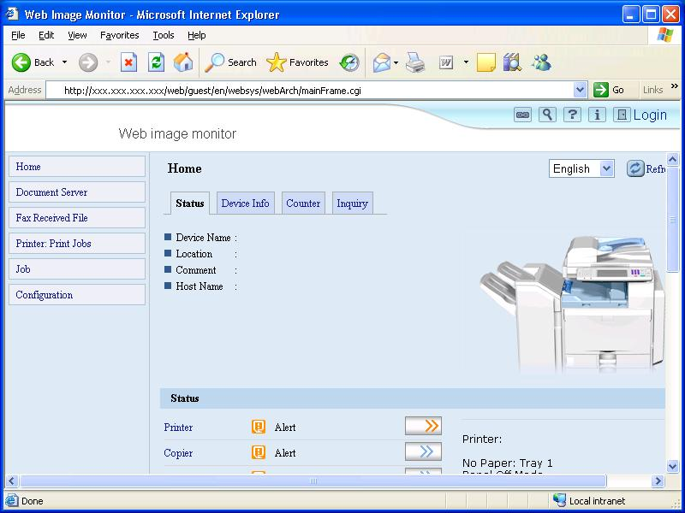
(2) In order to access Administrator mode, a username and password are required.
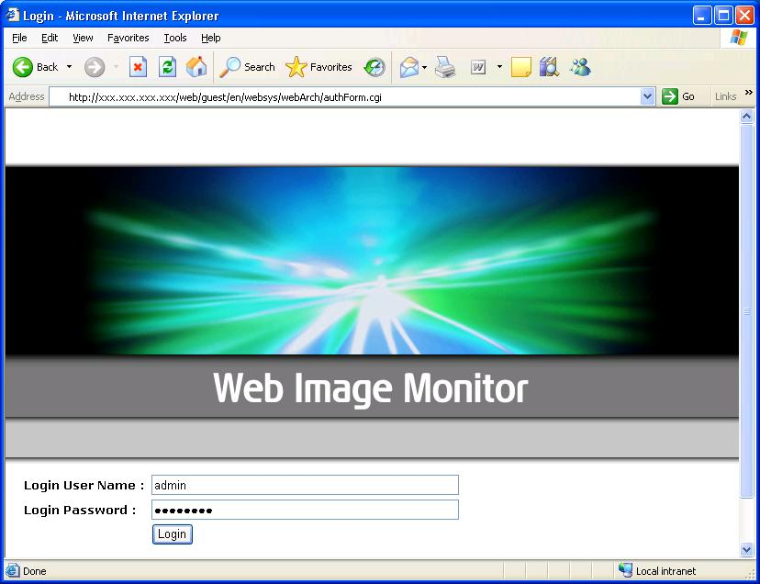

(3) Login to enter Administrator mode.
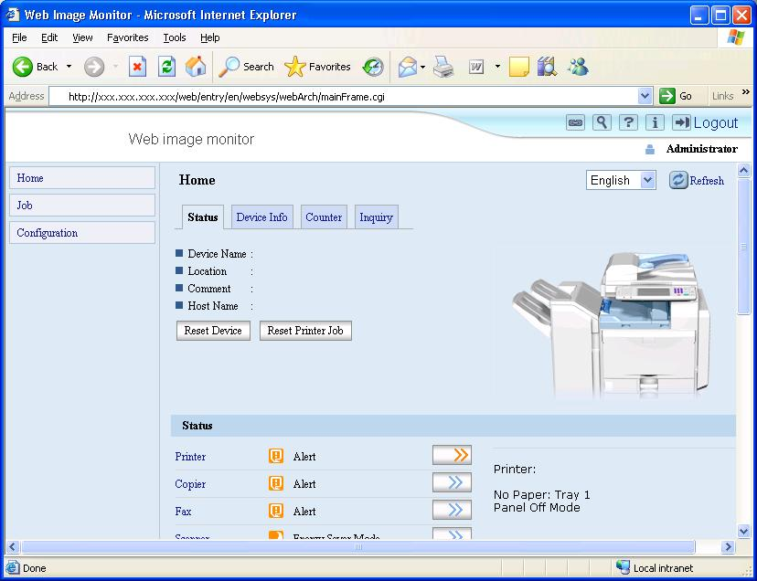
The 4 administrator types are identified as follows:

: Machine Administrator
: Network Administrator
: User Administrator
: File Administrator
(4) Click ‘Configuration’.
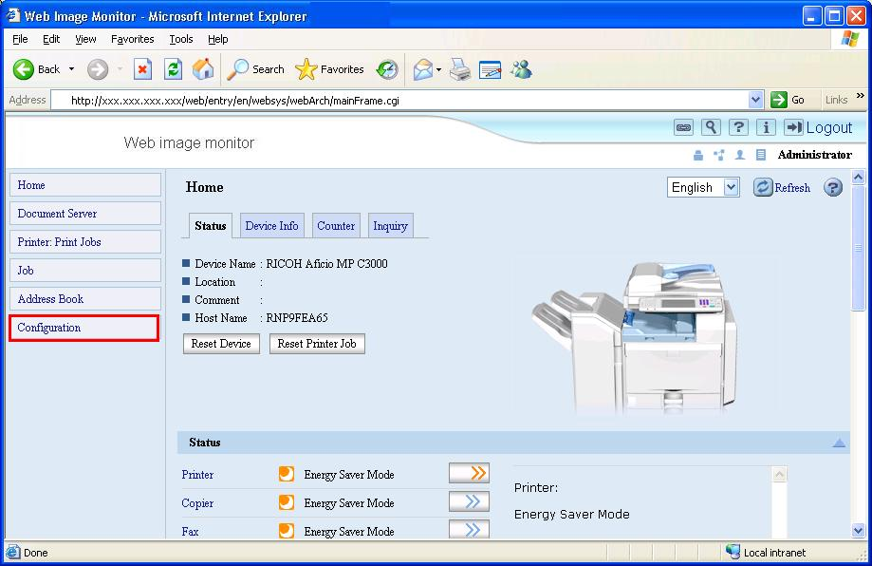

(5) To open the access control settings, click ‘Security’ -> ‘Access Control’.
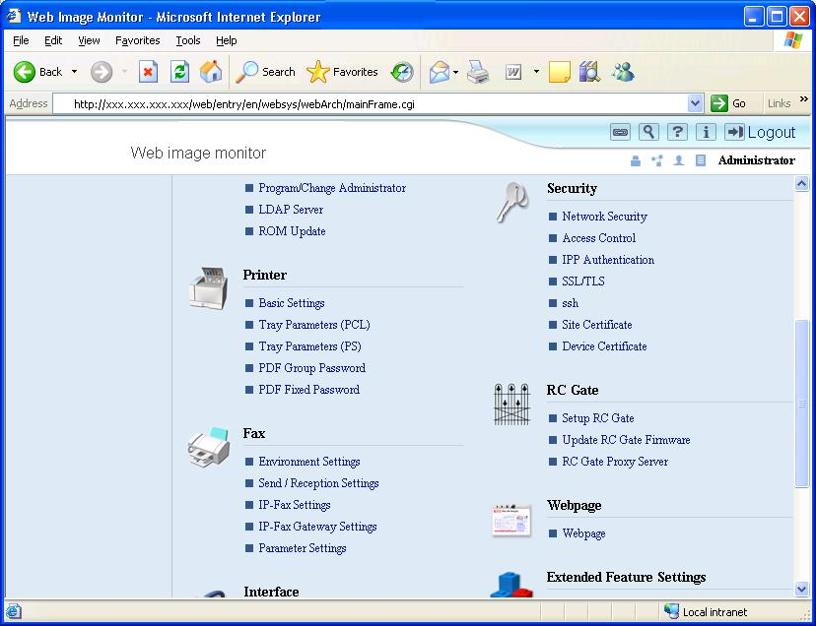
(6) Input the range of IP addresses that you wish to permit communication with.
Click the ‘OK’ button to commit the changes.
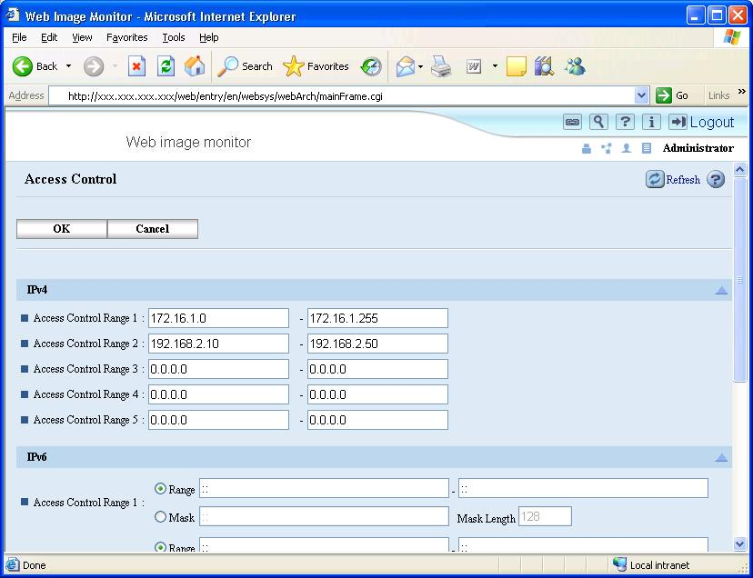

C)-2 The Purpose of Access Control – mshell
The following example is shown using the Windows XP telnet client.
- Access the products, using the command prompt. Launch the telnet command prompt from the Run menu as shown below.
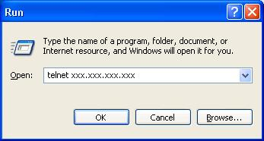

(2) Open the Maintenance Shell (mshell). A username and password will be required for this. Using the access command input the access control range.
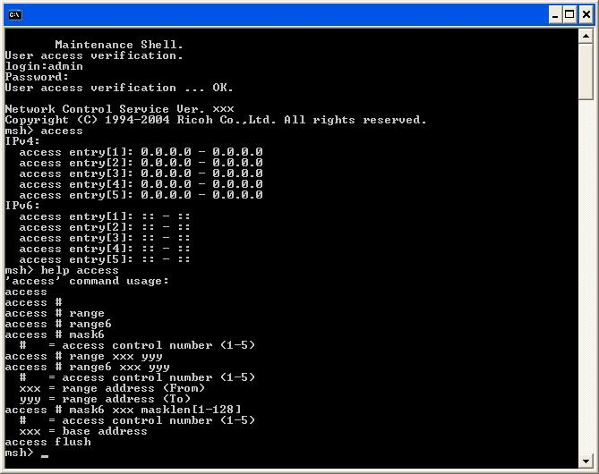
E.g.1 Input the following command to permit only access from 172.16.1.0 to 172.16.2.0
msh> access 1 range 172.16.1.0 172.16.2.0
E.g.2 Input the following command to clear all access ranges.
msh> access flush
(3) If changes have been made, the following question will appear before the user logs out. ‘Do you save configuration data?’ Input ‘yes’ to commit the changes. Input ‘no’ to discard them.
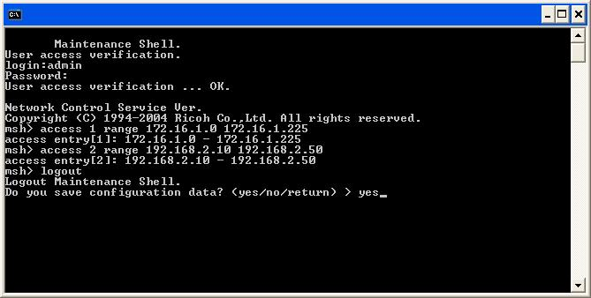
D) How to disable services
The following services can be enabled or disabled by selecting up or down.
TCP/IP, NetWare(*1), SMB(*2), Appletalk, LPR, FTP(*3), RSH/RCP, DIPRINT, WEB(Only mshell)(*4), SNMP(*5), IPP(*6), HTTP(Only mshell)(*7), ip1394, scsiprint, TELNET(Only Web Image Monitor), Bonjour(*8), SSL(*9), @Remote(Only mshell)(*10), RFU(Only mshell)(*11), NBT(*12), SSDP(*13), SFTP(*14)

*1; Netware; Setting Netware to down, disables the IPX/SPX protocol and NCP/IP. Therefore if Netware is down, printing in the IPX/SPX environment and in the pure IP environment is unavailable. LPR in NDPS and iPrint (IPP Printing) are unaffected.
*2; SMB; Setting SMB to down, closes NetBIOS-SSN (139/TCP) and NETBEUI service will be down. However affects only the server service. The client service is not affected. Therefore, if SMB is down, Scan to SMB can still be used.
*3; FTP; Setting FTP to down, closes FTP port (21/tcp). The FTP server service will be down but the FTP client function is still available. Therefore if this function is down, Scan to FTP is still available.
*4; web; Setting web to down, disables the Web Image Monitor. However even if this function is disabled, HTTP Port (80/tcp) will still be open. Therefore if this function is disabled, IPP printing using HTTP Port (80/tcp) is still available.
*5; SNMP; Setting SNMP to down, closes SNMP port (161/udp). In addition when SNMP is down, the SNMP trap function and SNMP function over IPX/SPX are not available.
*6; IPP; Setting IPP to down, disables the IPP printing function but doesn’t close IPP Port (631/tcp). Therefore if IPP is down, IPP printing using HTTP (80/tcp) is still available.
*7; HTTP; Setting HTTP to down, closes HTTP Port (80/tcp). Therefore, not only Web Image Monitor but also IPP printing using HTTP port (80/tcp) is disabled.
*8; Bonjour; Setting Bonjour to down makes Bonjour is unavailable and closes the MDNS port (5353/udp).
*9; SSL; Setting SSL to down, closes the HTTPS port. Therefore, Web Image Monitor and IPP printing using HTTPS port (443/tcp) are disabled.
*10; @Remote; This was mentioned in section “2.16. Others”. To disable @Remote, please close ports 7443 and 7444.
*11; RFU; Port 21/10020/10021 must be open in order to use RFU via Web Smart Device Monitor. Each port can be closed via mshell.
*12; NBT; Setting NBT to down, closes NetBIOS-NS (137/UDP) and NetBIOS-DGM (138/UDP).
*13; SSDP; Settings SSDP to down makes UPnP is unavailable and closes the SSDP port (1900/UDP)
*14; SFTP ; Settings SFTP to down makes SFTP is unavailable and closes the SFTP port (22/TCP)
D)-1 How to disable services – Web Image Monitor
Steps (1) to (4) are the same as C)-1.
(5) Click ‘Network’ -> ‘IPv4’ to access the IPv4 protocol settings. By default all protocols are enabled. Similarly, by clicking ‘Network’ -> ‘IPv6’, the IPv6 protocols can be enabled or disabled.

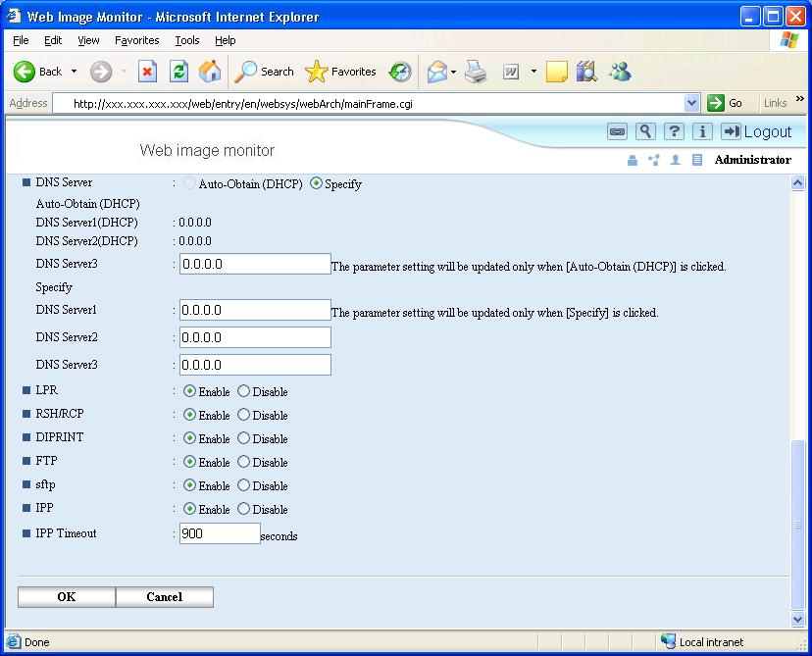
D)-2 How to disable services – mshell
(1) The procedure for this is the same as is shown in section C)-2
(2) Using the ‘set’ command, input the access control range.
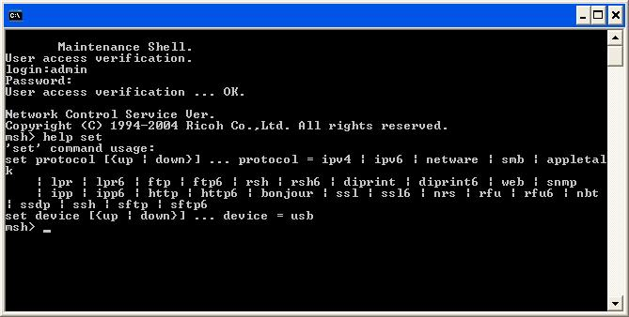
E.g.1 Input the following command to disable the HTTP protocol.
msh> set HTTP down
Note1: TELNET does not appear in the help menu.

(3) The procedure for this is the same as is shown in section C)-2
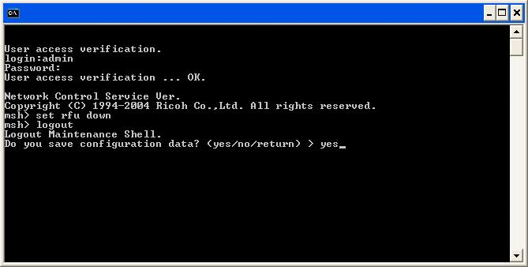
E) HTTP/HTTPS settings
Steps (1) to (4) are the same as C)-1.
(5) To access the SSL/TLS settings, click ‘Security’ -> ‘SSL/TLS’.
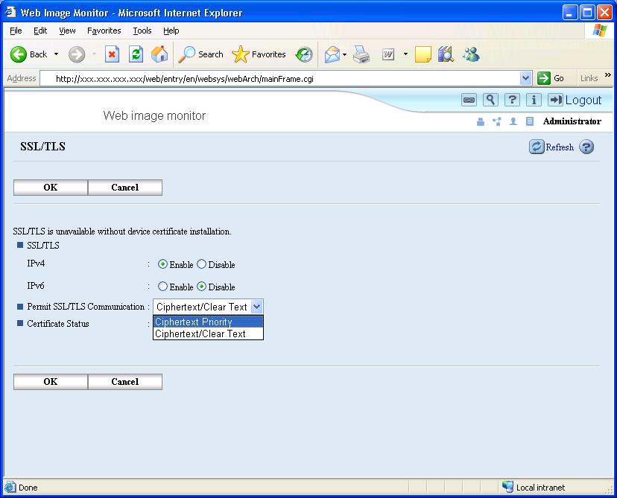

- Permit SSL/TLS Communication
Ciphertext/Clear Text: Permit both HTTPS and HTTP connections. No forwarding of HTTP to HTTPS.
Ciphertext Priority: Any incoming HTTP request that can be forwarded to HTTPS, will be forwarded. With this setting it will be possible to use HTTPS from Internet Explorer, Netscape Navigator, etc. (HTTP will be forwarded) but not using IPP from SmartDeviceMonitor for Client etc. (these requests can not be forwarded). If the request cannot be forwarded to HTTPS, HTTP will be permitted.
Ciphertext Only: Permit only HTTPS connections. All incoming HTTP requests will be forwarded to HTTPS. If the request cannot be forwarded, the connection will be rejected.

F)-1 SNMP settings – Web Image Monitor
Steps (1) to (4) are the same as C)-1.
(5) To access the SNMP (v1/v2) settings, click ‘Network’ -> ‘SNMP’.
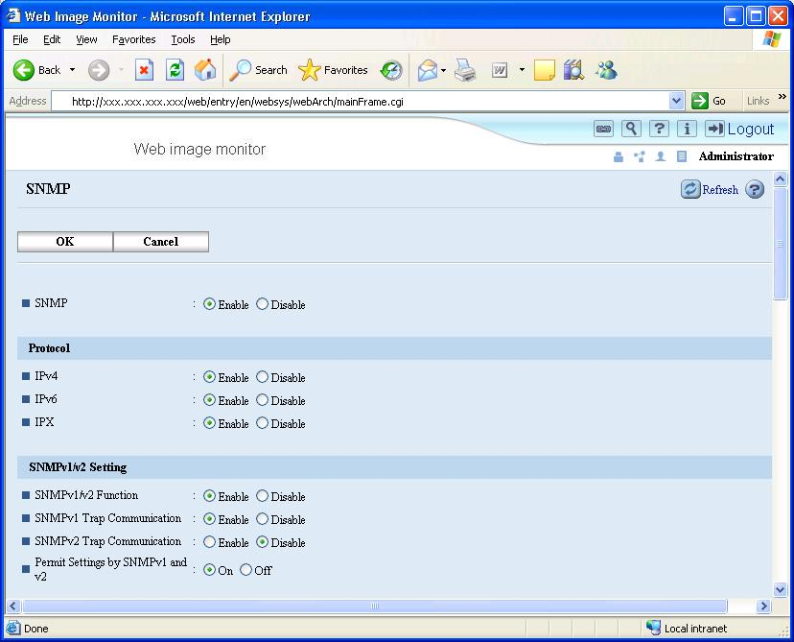

- SNMP
(This setting can be configured either from here or from the SNMPv3 settings.)
Enable: Opens the SNMP port
Disable: Closes the port completely. No SNMP communication of any version can be used.

- SNMP v1/v2 Function
Enable: Allows the use of SNMP v1/v2.
Disable: Does not allow connections using SNMP v1/v2. Because SNMP v1/v2 don’t have encryption or authorization, we recommend using ‘Disable’ for this setting unless absolutely necessary.

-Permit Settings by SNMP v1 and v2
On: This enables SNMP set. It is used to write changes to settings.
Off: This disables SNMP set. Only get will be permitted. Therefore, settings can be read but not changed.
(6) To access the SNMP v3 settings, click ‘Network’ -> ‘SNMP v3’.
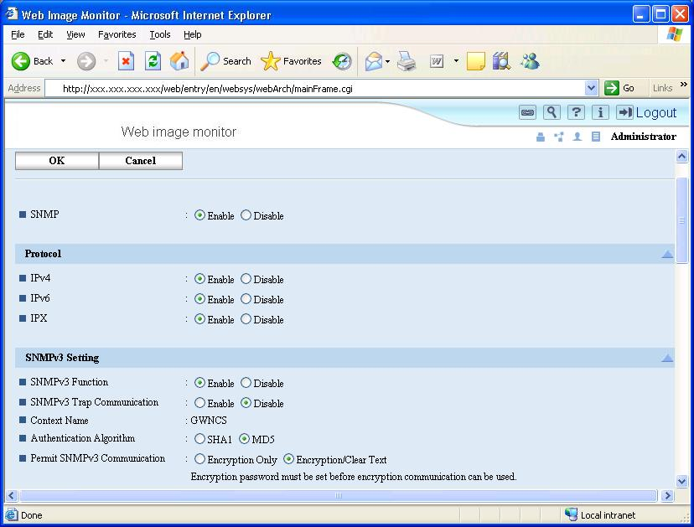

-SNMP
(This setting can be configured either from here or from the SNMPv1/v2 settings.)
Enable: Opens the SNMP port
Disable: Closes the port completely. No SNMP communication of any version can be used.

-SNMP v3 Function
Enable: Allows communication using SNMP v3.
Disable: Does not allow communication via SNMP v3.

-Authentication Algorithm
SHA1: Hashes the username and password using the SHA1 hashing algorithm.
MD5: Hashes the username and password using the MD5 hashing algorithm.

-Permit SNMPv3 communication
Encryption Only: The username and password must be encrypted using the hashing algorithm selected above.
Encryption/Clear Text: The username and password can be sent either encrypted or unencrypted.
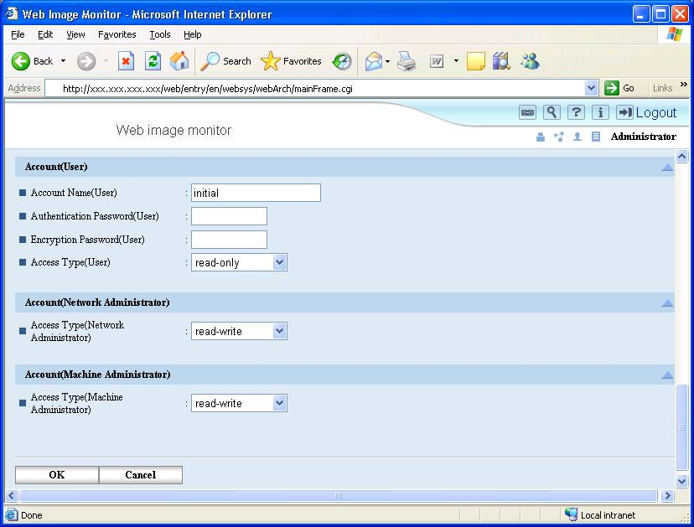

There are 3 different types of accounts that can be used for SNMPv3 connections. Only the User account can be fully configured here. For information about fully configuring the Machine and Network Administrator accounts, please refer to Appendix G.

Account Name (User): This is the username that the user will use to login to SNMPv3.
Authentication Password (User): This is the password that the user will use to login to SNMPv3.
Encryption Password (User): This is the key used for SHA1 or MD5 hashing of the username and password.

F)-2 SNMP settings – mshell
(1) The procedure for this is the same as is shown in section C)-2.
(2) You can configure SNMP settings using snmp commands from mshell. These commands can be displayed by typing ‘help snmp’ in mshell.
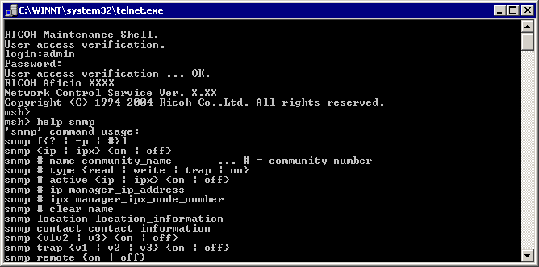
G) How to change administrator account settings – Web Image Monitor
Steps (1) to (4) are the same as C)-1.
(5) To access settings for the administrator accounts, click ‘Device Settings’ -> ‘Program/Change Administrator’.
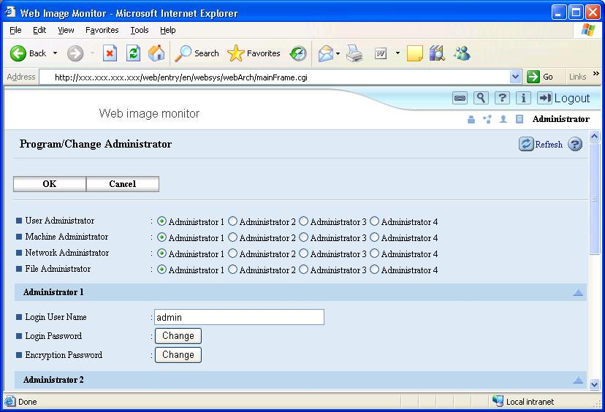

You can change MFP Administrator account settings from here.

These settings affect the Administrator logins for TELNET, Web Image Monitor and SNMP v3.
H) Network Security Level settings
H)-1. How to configure
Network Security Levels are settings-profiles designed to meet different levels of security in customer environments. The advantage to the Network Security Level settings is that they make the task of configuration easier. Customers can use the Network Security levels as is, or modify them to suit their needs. There are 3 levels to choose from:
[Level 0], [Level 1], [Level 2], and [User Settings]
[Level 2] – maximum security.
[Level 1] – moderate security for use in an office LAN.
[Level 0] – basic security for closed environments.
[User Settings] – manually defined settings.
Configuration of the Network Security Level setting:
Steps (1) to (4) are the same as C)-1.
(5) To access the Network Security Level setting, click ‘Security’ -> ‘Network Security’.
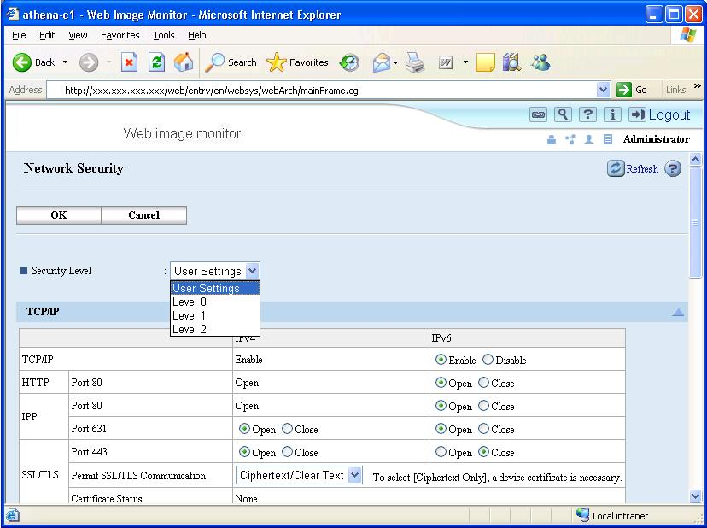

H)-2. Description of levels
 | Setting |  | Network Security Level
 |  |  | Level 0 | Level 1 | Level 2
Interface | IEEE 1394 SBP-2 |  | Enabled | Enabled | Disabled
Interface | Bluetooth |  | Enabled | Enabled | Disabled
Interface | IP over 1394 |  | Enabled | Enabled | Enabled
TCP/IP | TCP/IP |  | Enabled | Enabled | Enabled
TCP/IP | HTTP/HTTPS | Port 80 | Port open | Port open | Port open*1
TCP/IP | HTTP/HTTPS | Port 443 | Port open | Port open | Port open
TCP/IP | HTTP/HTTPS | Port 7443/7444 | Port open | Port open | Port open
TCP/IP | IPP | Port 80 | Port open | Port open | Port open *1
TCP/IP | IPP | Port 443 | Port open | Port open | Port open
TCP/IP | IPP | Port 631 | Port open | Port open | Port closed
TCP/IP | SSL | Encryption Mode | Ciphertext Priority | Ciphertext Priority | Ciphertext Only *2
TCP/IP | DIPRINT | Port 9100 | Port open | Port open | Port closed
TCP/IP | LPR | Port 515 | Port open | Port open | Port closed
TCP/IP | FTP | Port 21 | Port open | Port open | Port open
TCP/IP | SSH/SFTP | Port 22 | Port open | Port open | Port open
TCP/IP | Ricoh Original | Port 10021 | Port open | Port open | Port open
TCP/IP | RSH/RCP | Port 514 | Port open | Port open | Port closed
TCP/IP | SNMP | Port | Port open | Port open | Port open
TCP/IP | SNMP | SNMP v1/v2 (Read) | Enabled | Enabled | Disabled
TCP/IP | SNMP | SNMP v1/v2 (Write) | Enabled | Disable | Disabled
TCP/IP | SNMP | SNMP v3 | Enabled | Enabled | Enabled
TCP/IP | SNMP | SNMP v3 with Encrypt | Automatic | Automatic | Ciphertext Only
TCP/IP | TELNET | Port 23 | Port open | Port closed | Port closed
TCP/IP | SSDP (UPnP) | Port 1900 | Port open | Port open | Port closed
TCP/IP | mDNS | Port 5353 | Port open | Port open | Port closed
TCP/IP | NBT | Port 137/138 | Port open | Port open | Port closed
TCP/IP | SMB | Port 139 | Port open | Port open | Port closed
Netware | Netware |  | Enabled | Enabled | Disabled
AppleTalk | AppleTalk |  | Enabled | Enabled | Disabled
*1: The port is open but cannot be used to access the web service because the SSL setting is Ciphertext Only.
*2: If the SSL setting is Ciphertext Only, the products will still accept IPP jobs using port 80.
I) Wireless LAN settings
WEP, WPA-PSK, and WPA (802.1X) can be configured via the operation panel, telnet, or Web Image Monitor. However, the WPA (802.1X) certificate settings can only be configured in Web Image Monitor.

I – 1) Wireless LAN settings – Web Image Monitor
Steps (1) to (4) are the same as C)-1.
(5) Click ‘Interface’ -> ‘Wireless LAN Settings’.
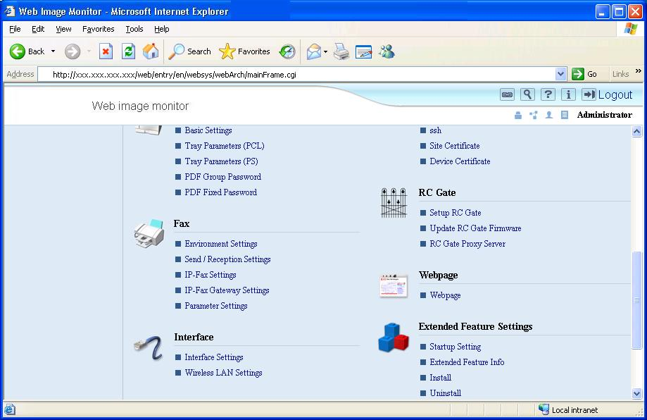
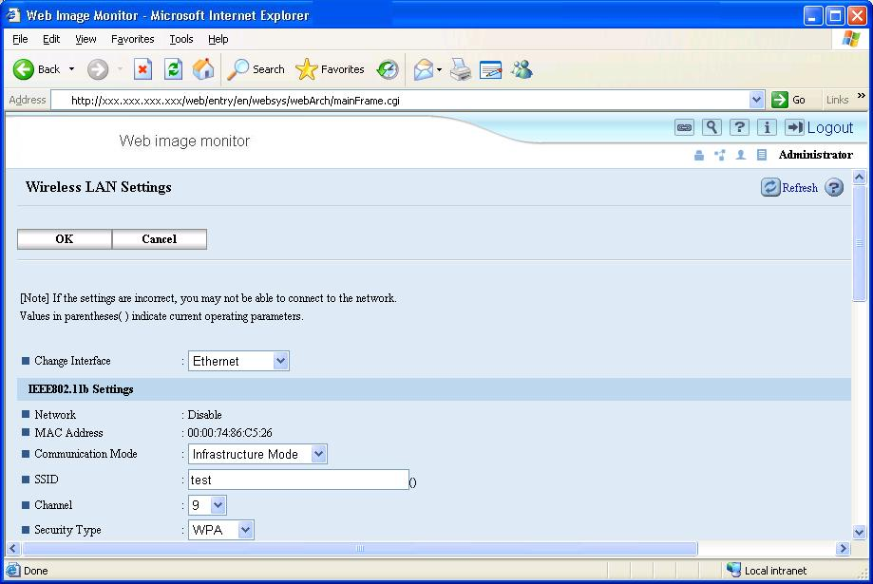
- Change Interface
Ethernet: Enable Ethernet
IEEE802.11b: Enable IEEE802.11b

[IEEE802.11b Settings]
- Network
Enable: IEEE802.11b is enabled
Disable: IEEE802.11b is disabled

- MAC Address
Displays the MAC Address of the Wireless LAN board.

- Communication Mode
802.11 Ad-hoc Mode: Ad-hoc connection using SSID.
Ad-hoc Mode: Ad-hoc connection without using SSID.
Infrastructure Mode: Communicates using an access point and SSID.

- Channel
Sets the radio frequency used. If Infrastructure mode is being used, this setting is unimportant as the channel defined by the access point will be used automatically.

- Security Type
Disable: No encryption of data.
WEP: Uses WEP security.
WPA: Uses WPA security.

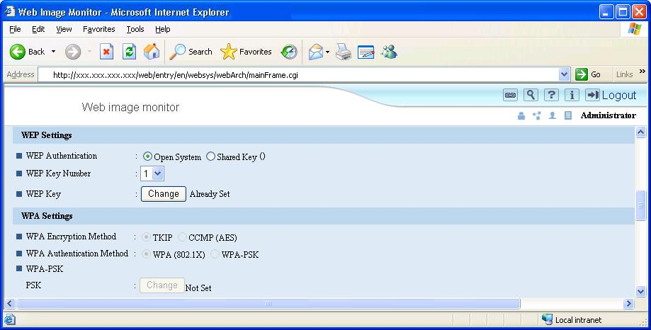
[WEP]
WEP settings can only be configured if ‘WEP’ is selected in ‘IEEE802.11b Settings’ -> ‘Security Type’.

- WEP Authentication
Open System: Anyone with the correct SSID can join the network.
Note: As the system uses a WEP key, simply joining the network is not enough to be able to receive send readable communications.
Shared Key: WEP key required to join the network.

- WEP key number
Up to 4 WEP keys can be saved in the MFP. Select one of them.

- WEP Key
Set the WEP key used for WEP encryption. If 64-bit key is used, 10 hexadecimal characters or 5 alphanumeric characters need to be entered. If a 128-bit key is used, 26 hexadecimal characters or 13 alphanumeric characters need to be entered.

[WPA]
WPA settings can only be configured if ‘WPA’ is selected in ‘IEEE802.11b Settings’ -> ‘Security Type’.

- WPA Encryption Method
TKIP: Uses TKIP.
CCMP: Uses CCMP.

- WPA Authentication Method
WPA (802.1X): Uses WPA (802.1X).
WPA-PSK: Uses WPA-PSK.

- WPA-PSK
PSK: Sets the pre-shared key used.

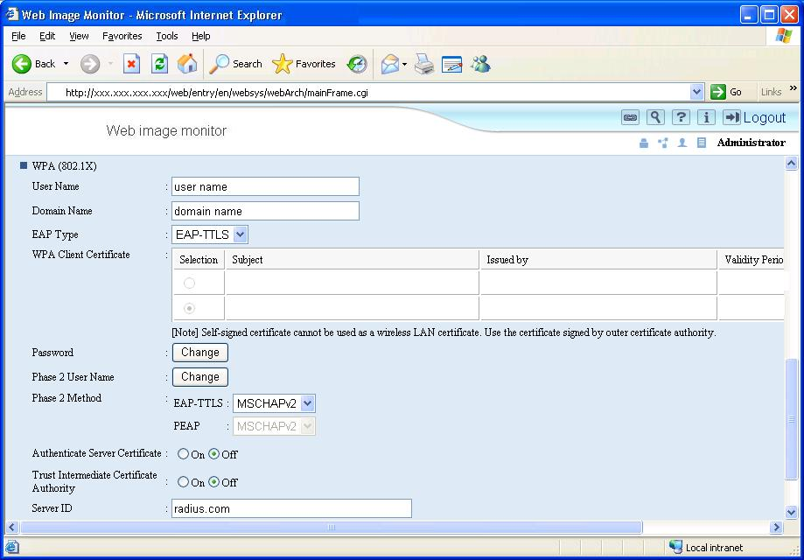

- WPA (802.1X)
User Name: This is the username used for EAP authentication on the Radius server.
Domain Name: This is the domain name used for the authentication on the Radius server.
- EAP Type: EAP-TLS, LEAP, EAP-TTLS, or PEAP
- WPA Client Certificate: WPA 802.1X certificate.
- Password: This is the password used for EAP authentication on the Radius server.
- Phase 2 User Name: This is the user name used in phase 2 of EAP-TTLS and PEAP.
- Phase 2 Methods (EAP-TTLS): If EAP-TTLS is selected as the EAP type, a Phase2 authentication method must be selected.
Select from CHAP, MSCHAP, MSCHAPv2, PAP, or MD5
- Phase 2 Methods (PEAP): If PEAP is selected as the EAP type, a Phase2 authentication method must be selected.
Select from MSCHAPv2 or TLS.

- Authentication Server Certificate: Select whether the Radius Server is required to send a certificate to connecting WPA (802.1x) client.
- Trust Intermediate Certificate Authority: Select whether the certificate provided by the Radius Server must be signed by a trusted CA.
- Server ID: This is the CN (or the DC) of server certificate.

I – 2) Wireless LAN settings – mshell
- The procedure for this is the same as is shown in section C)-2
- Configure Wireless LAN settings using ‘wiconfig’ commands from mshell. For a list of commands, type ‘help wiconfig’ in mshell.
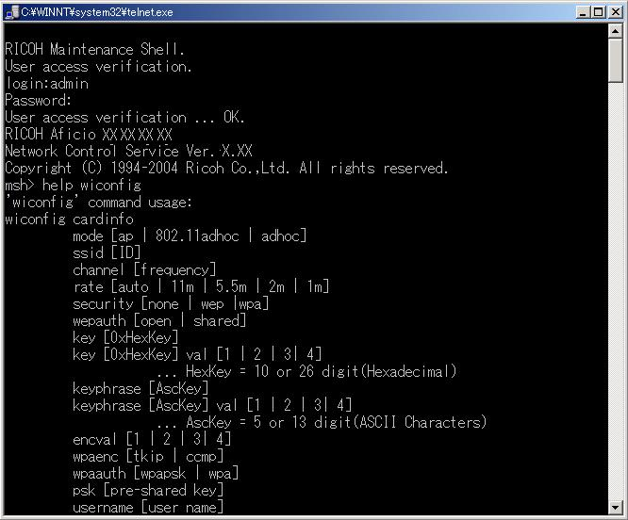
5. Reference list
RFC: HTTP://www.faqs.org/rfcs/
CVE: HTTP://cve.mitre.org/
CERT: HTTP://www.cert.org/
CIAC: HTTP://www.ciac.org/ciac/
SecurityFocus: HTTP://www.securityfocus.com/
NESSUS: HTTP://www.nessus.org/index2.html

