Security White Paper for
Streamline NX Authentication and Accounting Manager Version 1.2.0.0

Solution Value proposition Section
Global Technology Support Department
Service and Support Center
Global Marketing Group

Document version
SLNXAAMV1.2.0-1.0

Notice:
This document may not be reproduced or distributed in whole or in part, for any purpose or in any fashion without the prior written consent of Ricoh Company Limited. Ricoh Company Limited retains the sole discretion to grant or deny consent to any person or party.

Copyright © 2011 by Ricoh Company Ltd.

All product names or product illustrations, including desktop images, used in this document are trademarks, registered trademarks or the property of their respective companies. They are used throughout this book in an informational or editorial fashion only. Ricoh Company, Ltd. does not grant or intend to grant hereby any right to such trademarks or property to any third parties. The use of any trade name or web site is not intended to convey endorsement or any other affiliation with Ricoh products.

Although best efforts were made to prepare this document, Ricoh Company Limited makes no representation or warranties of any kind with regards to the completeness or accuracy of the contents and accepts no liability of any kind including but not limited to performance, merchantability, fitness for any particular purpose, or any losses or damages of any kind caused or alleged to be caused directly or indirectly from this document.

Document version history:
Version | Date of Issue | Revision
1.0 | August, 2011 | - Initial Release

1. Introduction 4
2. System 6
3. Network Protocols 8
3.1 Ports and Protocols 8
3.2 Recommended Precautions 9
4. Data Flow and Storage 10
4.1. Data Storage and Data Access Permissions - AAM (Embedded) 10
4.1.1 Stored Data 10
4.1.2 Data Access Permissions 10
4.1.3 Caution 11
4.2. Data Storage and Data Access Permissions - AAM (Server) 12
4.2.1 Stored Data 12
4.2.2 Data Access Permissions 12
4.2.3 Caution 13

1. Introduction

This paper provides security information about Streamline NX Authentication and Accounting Manager (AAM), which is comprised of two primary components: AAM Server (AAM-S) and AAM Embedded (AAM-E).

AAA (Authentication/Authorization/Accounting) Security

Authentication

The authentication methods and the operation are explained in the following table.

Operation | Authentication
Panel | Authentication runs with entered username and password. | - Kerberos Authentication  - LDAP Authentication
Card | [Enter password]  The username is obtained from the Card ID.  After using the card, the user must enter a  Password from the operation panel.  [Do not enter password (Proxy User)]  The username is obtained from the Card ID.  Authentication is performed by a proxy user that searches the LDAP directory for username.  If the username exists, authentication succeeds.  [Do not enter password (Saved password)]  The username is obtained from the Card ID.  The LDAP server is accessed to verify the username as well as the stored password for that user. | - Kerberos Authentication  - LDAP Authentication
Printer | If Secure Print Manager or Direct Print is used, it is possible to print.

About the Saved Password function
If this function is enabled, when authentication succeeds for a user for the first time when using the operation panel, the password will be encrypted (AES128) and saved in the SQL DB.
The saved password cannot be accessed or changed from the operation panel, even with administrator privileges.
If the user’s password is changed, the user needs to login again (using the new password) from the operation panel in order to update the password saved in the DB of AAM-S.

Authorization

Authorization (privileges) is assigned to individual users or to groups.
When a user is newly registered to the user information table kept by AAM-S, the user will be assigned default privileges.

Accounting

The Accounting logs (username, page count, job type, etc.) are temporarily stored in AAM-E’s HSQL DB. AAM-E sends the information to AAM-S for use by Streamline NX’s Report Generator.
There is a special procedure for collecting the accounting logs from LPs when using SPM. Please see the SPM white paper for details.

2. System

This section describes the security of data stored on the HDD and as it travels over the network.

[Streamline NX Authentication and Accounting Manager (Embedded)]
Streamline NX Authentication and Accounting Manager (Embedded)

HSQL
Administrative
Service
HTTP(S)
Administrator
Service Technician
Accounting Service
Authentication Service
Provider
HTTPS
HTTPS
Admin Tool Operations
Configuration
Authentication
Streamline NX
Authentication and Accounting Manager (Server)
Streamline NX
Administration Manager
Accounting Information

[Streamline NX Authentication and Accounting Manager (Server)]
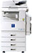
User/Group Table
Login Service
Administrative Tool
SQL
Server
Administrator / Service Technician
System
Configuration
Log
Streamline NX
Report Generator
LDAP
Kerberos
Authentication
Authentication
LDAP(S)
Kerberos
Authentication
Service Provider
Active Directory
Open LDAP
Streamline NX
Administration Manager
HTTP(S)
HTTPS
HTTPS
HTTPS
ACL Service
SQL (Account Log)
User Information
User Information
Configuration
DebugLog
ACL Check
Accounting Service
Authentication
HTTPS
Account Log
Account Log
HTTPS
Streamline NX
Secure Print Manager
(Server)
Authentication
HTTPS
KDC
Streamline NX
Scan and Fax Manager
(Server)
Streamline NX Authentication and Accounting Manager (Server)

3. Network Protocols

3.1 Ports and Protocols

[AAM (Embedded)]
Features | Protocol | Service | Port No | Destination | Description
Administrative Service | TCP | http | 8080 | From client PC/ADM to AAM (Embedded)
Administrative Service | TCP | https | 51443 | From client PC/ADM to AAM (Embedded) | Used only when SSL is enabled
Authentication Service Provider,  Accounting Service | TCP | https | 8443 (*1) | AAM (Server)
(*1) Default port. This can be changed.

[AAM (Server)]
Features | Protocol | Service | Port No | Destination | Description
Administrative Tool | TCP | http | 8080 (*1) | AAM (Server)
Administrative Tool | TCP | https | 8443 (*1) | AAM (Server)
Login Service | TCP | https | 8443 (*1) | AAM (Server)
Authentication  Kerberos | TCP | Kerberos | 88 | KDC
Authentication  Kerberos | UDP | Kerberos | 88 | KDC
Authentication  LDAP Authentication  (Other LDAP Servers) | TCP | LDAP | 389 (*1) | LDAP server
Authentication  LDAP Authentication  (Other LDAP Servers) | TCP | LDAPS | 636 (*1) | LDAP server
SQL Server | TCP | http | (*2) | DB server
(*1) Default port. This can be changed.
(*2) A random open port on the SQL server (1024 – 65536) is used.

The current SQL server port can be found using:
“SQL Server Configuration Manager”→ “SQL Server Network Configuration” → “Protocols for <Instance Name>” → “TCP/IP” → “IP Addresses” → “IP ALL” → “TCP Dynamic Ports”.
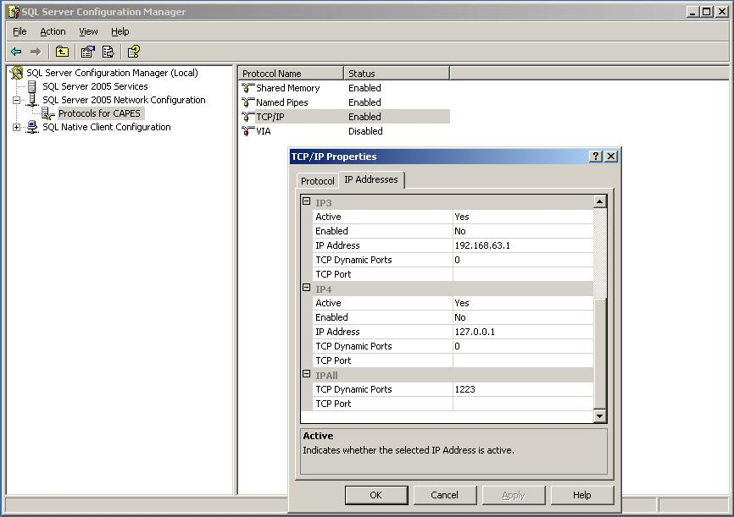

3.2 Recommended Precautions

[Using the AAM-E Administrative Service]
AAM-E can be accessed from a browser using either http or https.
When using http, the password sent over the network is not encrypted.
We recommend using https for security purposes.

Streamline NX Administration Manager only uses https to send configuration information to AAM-E.

AAM-E uses TLS v1.0 when https is enabled.

[Using the AAM (Server) Administrative Tool]
AAM-S can be accessed from a browser using either http or https. For enhanced security, using https is recommended.

AAM-S only uses https to handle requests from AAM-E, Streamline NX Administration Manager,
and Streamline NX Scan and Fax Manager. AAM-S uses TLS v1.0 for https connections.

[Authentication Security]
For enhanced security, using https is recommended.

AAM-S uses TLS v1.0 for communication with LDAP authentication servers when LDAPS is used.
If Kerberos is used to access an AD authentication server, the encryption used by AAM-S depends on the security level of the authenticating AD server (RC4-HMAC/AES128, etc.).

4. Data Flow and Storage

4.1. Data Storage and Data Access Permissions - AAM (Embedded)

4.1.1 Stored Data
Data Type | Transmitted Data | Specification
System Configuration | Server settings, accounting settings, Admin information (Username, Password), Service information (Username, Password), Server certificate, etc. | Admin privileges are required in order to import/export the system configuration file. All passwords in the system configuration are encrypted using DES.
Accounting Log (HSQL Database) | Accounting information (Usercode, job type, etc.)  Device information (IP address, Device code, Model code) | Service privileges are required in order to export the log file. Access from other SDK applications or via a remote connection is not available. The database and file are not encrypted.
Accounting Error Log | Accounting error information (Usercode, job type, etc.) | Service privileges are required in order to export the log file. The file is not encrypted.
Event Log | Operation information (Date, Event code, PC information, Username, etc…) | Service privileges are required in order to export the log file. The file is not encrypted.

4.1.2 Data Access Permissions
Data | Account Type | Permission | Description
System Configuration | Administrator | Read  Edit | Managed using the web UI or Streamline NX Administration Manager.
Accounting Log  (HSQL Database) | Service (*1) | Read | The service account can only export the accounting log in a CSV format.
Accounting Log  (HSQL Database) | System | Write  Edit  Delete | The system generates the file if it does not exist.  The system edits the logs when accounting data is generated.  The system deletes the logs after the logs have been sent to the server. (*2)
Accounting Error Log | Service (*1) | Read | The service account exports the accounting error log as a ZIP archive.
Accounting Error Log | System | Write  Edit  Delete | The system generates the file if it does not exist.  The system edits the file when an accounting error occurs. The log supports up to 10240 entries. When this limit is reached, the oldest information is overwritten.
Event Log | Service (*1) | Read | The service account exports the event log as a ZIP archive.
Event Log | System | Write  Edit  Delete | The system generates the file if it does not exist.  The system edits the file when an operation occurs.  Up to 5 1MB files are used to store the log data.
(*1) SSL is recommended.
(*2) Accounting logs are sent to the server according to the following rules:

Timing | Target accounting logs
At startup | All current accounting logs.
At user logout | All current accounting logs for the user.
Periodic processing | At the specified interval (Count Interval).
FAX transmission | The accounting logs for the transmitted fax.

4.1.3 Caution

[Backup]
Regular backups are recommended for the System Configuration file.
Backups are recommended for the Accounting Log file and the Accounting Error Log file in case of database failure.

4.2. Data Storage and Data Access Permissions - AAM (Server)

4.2.1 Stored Data
Data | Specification
SQL Server Database | An unique account is used to access the SQL server.  When installing AAM-S, the HostName/DB Name/Instance Name/Account/Password are set.  The User/ADM Administrator/Web UI’s Service password is encrypted using AES128.
Import User Information Log | Admin privileges are required in order to export the User Information log. The log is not encrypted.
Import Group Authorization Information Log | Admin privileges are required in order to export the Group Authorization Information log. The log is not encrypted.
Delete Disabled User Log | Admin privileges are required in order to export the Disabled User log. The log is not encrypted.
Delete Count Data Log | Admin privileges are required in order to export the Count Data log. The log is not encrypted.
Info Log File | Service privileges are required in order to export the Info Log file. The log is not encrypted.
Debug Log File | Service privileges are required in order to export the Debug Log file. The log is not encrypted.

4.2.2 Data Access Permissions
Data | Account type | Permission | Description
SQL Server Database | Administrator | Write  Edit  Delete | Managed using the Administrative Tool.
SQL Server Database | User | Write | For Card Registration (AAM-E)
Export/Import User Information Log | Administrator (*) | Read | The admin account can export the User Information log as a ZIP archive.
Export/Import User Information Log | System | Write  Delete | When users are imported, the System account logs the results.
Export/Import Group Authorization Information Log | Administrator (*) | Read | The admin account can export the Group Authorization Information log as a ZIP archive.
Export/Import Group Authorization Information Log | System | Write  Delete | When Group Authorization information is imported, the System account logs the results.
Export/Delete Disabled User Log | Administrator (*) | Read | The admin account can export the Disabled User log as a ZIP archive.
Export/Delete Disabled User Log | System | Write  Delete | The system account can write new logs and delete the old log.
Export/Delete Accounting Data Log | Administrator (*) | Read | The admin account can export the Delete Accounting Data log as a ZIP archive.
Export/Delete Accounting Data Log | System | Write | The system account can write new logs and delete the old log.
Info Log File | Service (*) | Read | The service account can export the Info Log, which contains 2 days worth of entries, as a ZIP archive.
Info Log File | System | Write  Delete | Generates up to 10 days of logs and updates everyday.
Debug Log File | Service (*) | Read | The service account can export the Debug Log, which contains 2 days worth of entries, as a ZIP archive.
Debug Log File | System | Write  Delete | Generates up to 10 days of logs and updates everyday.
(*) SSL is recommended.

4.2.3 Caution

[Resource Protection]
The security of AAM-S depends on the security of the server on which it is hosted. In order to protect the system, it should be kept in a secure location, physical access should be limited. Also, some sort of virus/malware protection is recommended.

[Backup]
Regular backups are recommended. At a minimum, backups should include the following:

Streamline NX Authentication and Accounting Manager (Server): User/Group Attributes

